DATA BASE CONSULTANTS (DBC)

Project : Community Service Organization (CSO)

Report by: Alexander Sato

Date: May 5, 2020

Subject: Final Deliverable

Status: The database is now feature complete and ready for deployment. Users can insert data, modify data, and delete data. The program contains all relevant reports as well as a page dedicated to common views. Common reports have advanced features to allow better business intelligence integration. A user help page has been implemented to assist acclimation. All input forms contain validation. The next step is integration and implementation. The database will be monitored in day-to-day use to identify any issues with the final system. A follow up report as well as user interviews will be conducted to address end-user concerns.

**Table of Contents**

Features and Benefits 3

User Operating Instructions 4

Sample Screen Index 5

User Help 35

Data Dictionary 37

Entity Relationship Diagrams 54

Table Structure Printout 56

Program Documentation 75

Diagram and Description of Program 76

SQL Printouts 77

Sample Data Printout 92

**User Features & Benefits**

* Users can access reports and forms for each aspect of the database for business intelligence.
* Users can sort tables and reorder columns to better arrange relevant data.
* Users can create new attributes to expand the database when needed.
* Users can edit existing attributes to update the database when needed.
* Users can delete attributes to clean up the database as needed.
* Users can generate charts and pivots for each form for business intelligence.
* A common views page has been added to aggregate views in an easy to find page for user clarity and simplicity.
* A user help page has been implemented to teach and assists users.
* Input validation has been added to keep user edits and inputs consistent with the database dictionary.

**User Operating Instructions**

Upon log in, the user is greeted by the home screen. All navigation is handled by the left hand navigation menu. Each page is grouped in categories, to drill down click the downwards arrow. Click the text to access the page related to the title. To add a new attribute, click on the corresponding Create/Edit button from the navigation bar or go to the related page and click Create on the page itself. To edit or delete attributes go to the corresponding page, find the attribute you wish to edit and click the pencil. If you are editing, make your changes in the corresponding boxes and click the save button. If you are deleting, click the delete button. Further actions can be made using the action bar for interactive reports. Common views are congregated in the common views page. Help is accessed with the help page on the main navigation bar.

**Sample screens Index**

Create/Edit Volunteer (Page 20) 6

Create/Edit Volunteer Skills (Page 28) 7

Create/Edit Phone (Page 8) 8

Create/Edit Project (Page 21) 9

Create/Edit Project Category (Page 26) 10

Create/Edit Assignment (Page 24) 11

Create/Edit Project Offering (Page 23) 12

Create/Edit Project Skill Requirement (Page 27) 13

Create/Edit Agency (Page 12) 14

Create/Edit Agency Category (Page 25) 15

People (Page 2) 16

Volunteers (Page 5) 17

Project for Volunteer (Page 9) 18

Phone (Page 8) 19

Skill (Page 10) 20

Project Offering (Page 4) 21

Project (Page 7) 22

Category for Project (Page 14) 23

Assignment (Page 16) 24

Agency (Page 6) 25

Category for Agency (Page 12) 26

Volunteer Skills (Page 17) 27

Total Hours Worked by Year (Page 17) 28

Hours Worked by City (Page 17) 29

Hours Worked by Volunteer (Page 17) 30

Agency by City (Page 17) 31

Agency Projects (Page 17) 32

Project Hours (Page 17) 33

Project Leaders (Page 17) 34

Create/Edit Volunteer (Page 20)

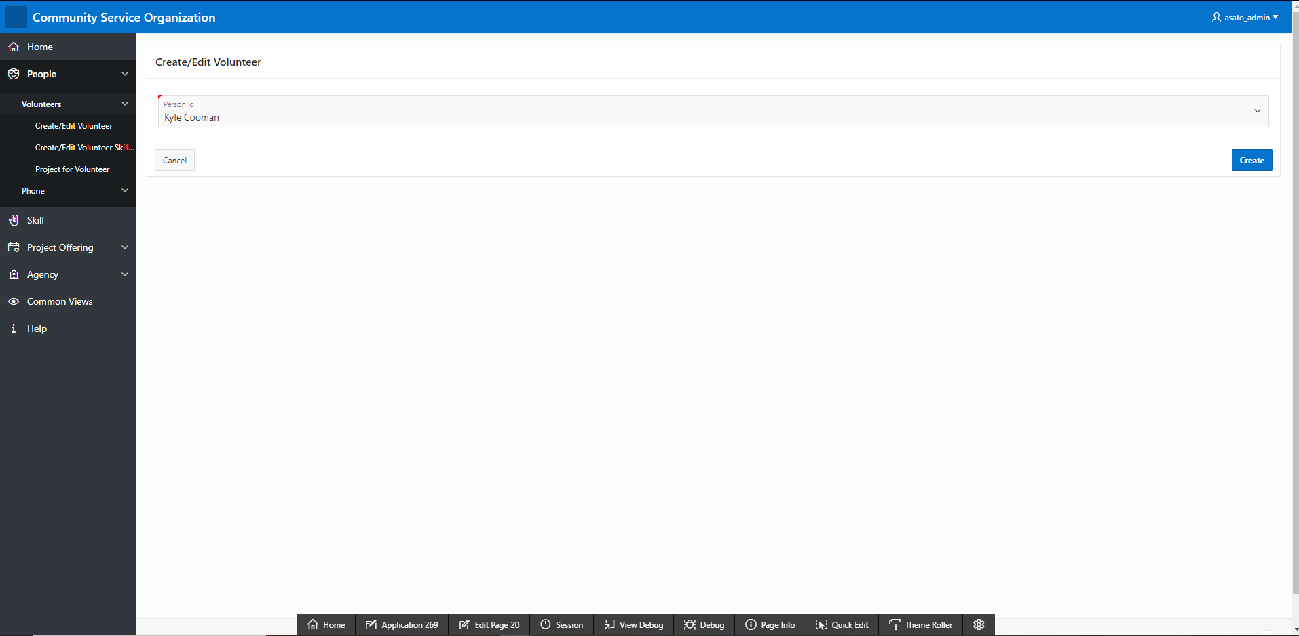

Create/Edit Volunteer Skills (Page 28)

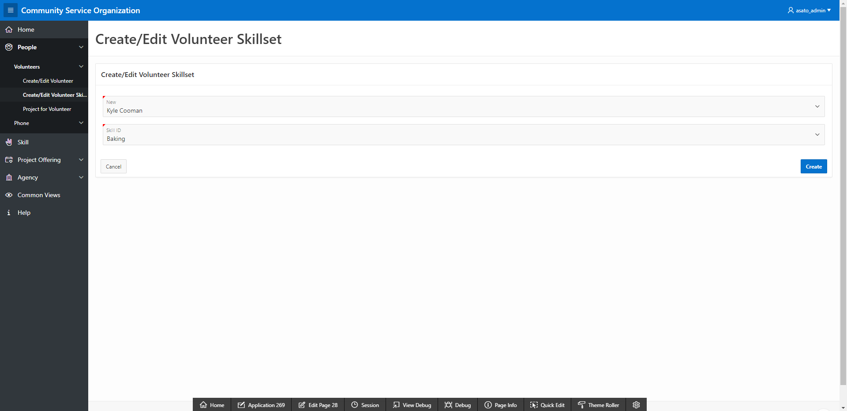

Create/Edit Phone (Page 8)

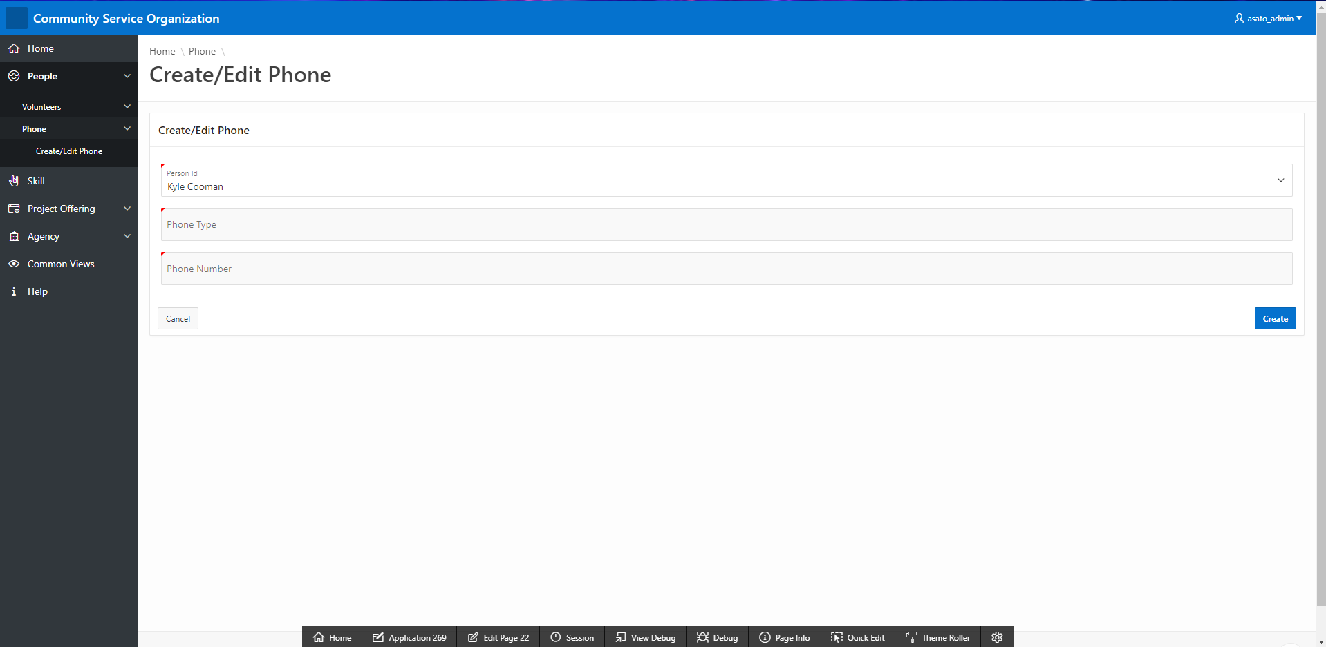

Create/Edit Project (Page 21)

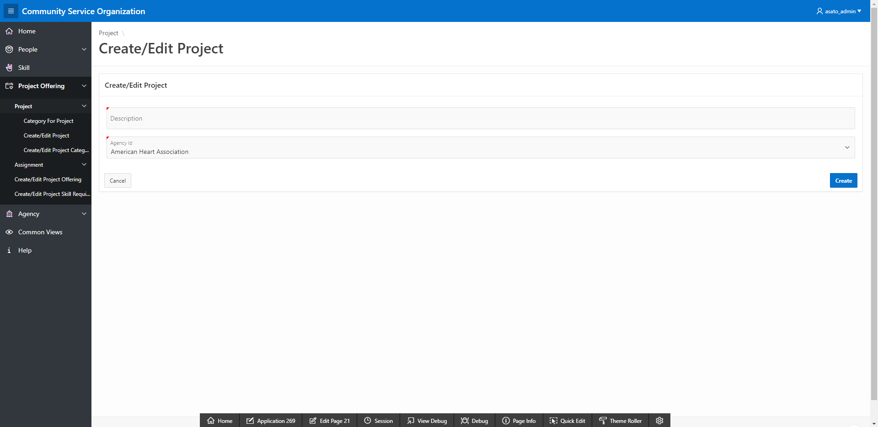

Create/Edit Project Category (Page 26)

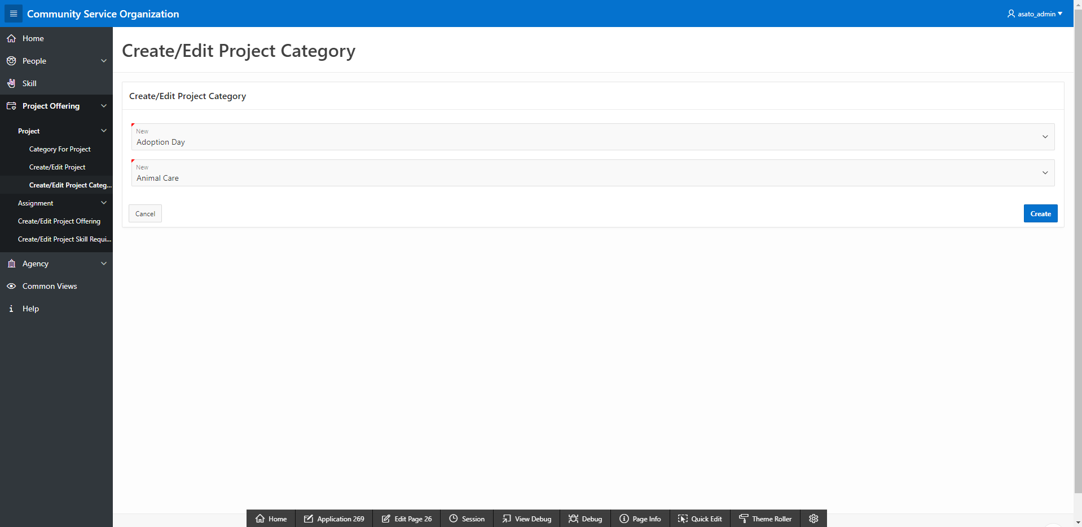

Create/Edit Assignment (Page 24)

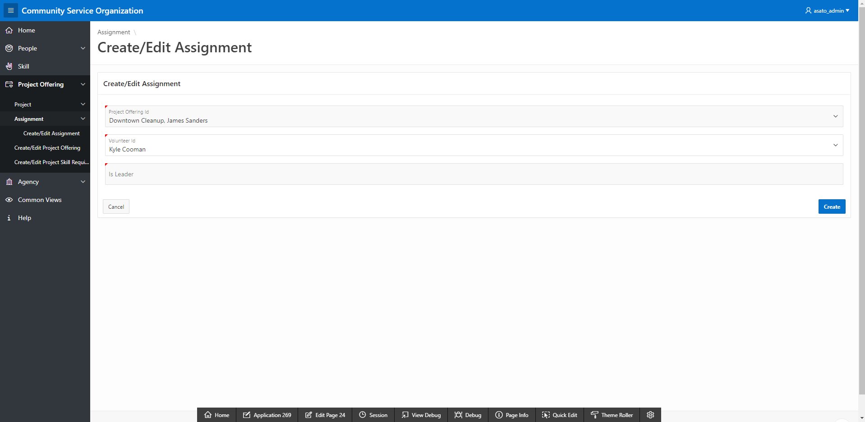

Create/Edit Project Offering (Page 23)

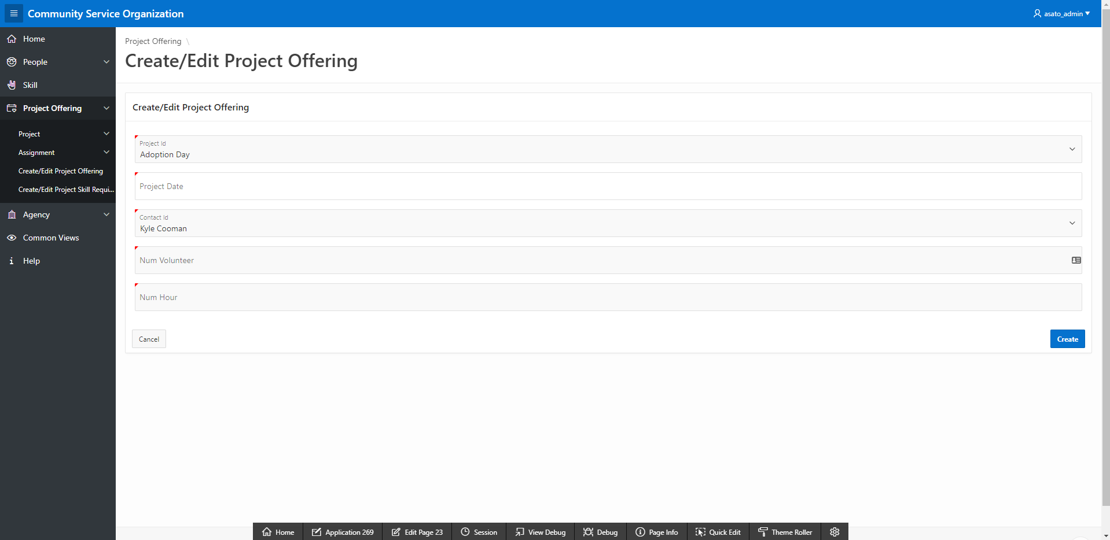

Create/Edit Project Skill Requirement (Page 27)

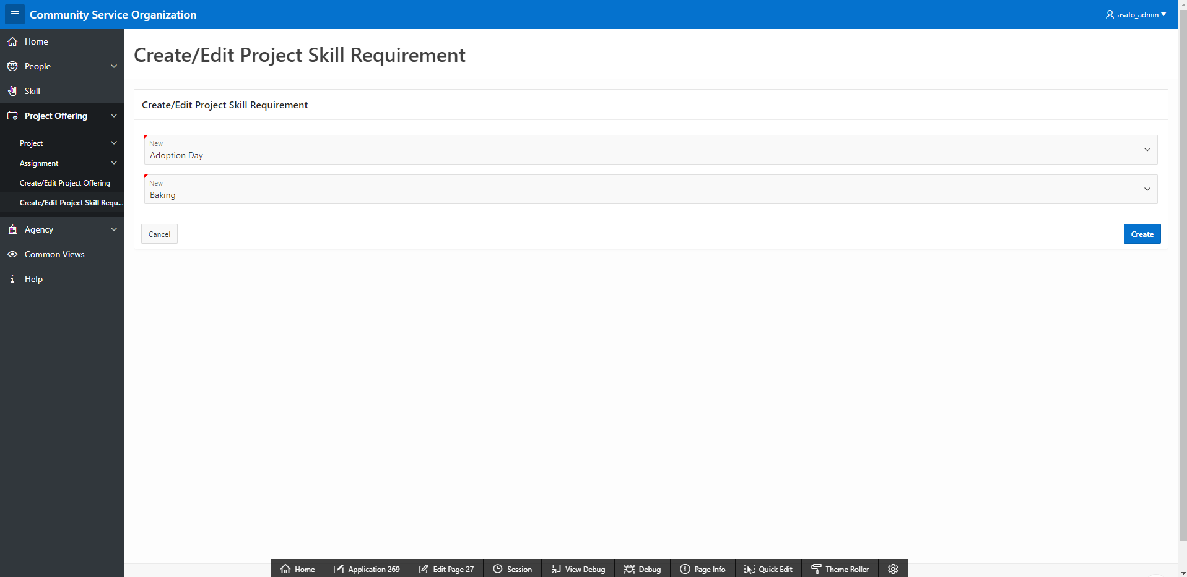

Create/Edit Agency (Page 12)

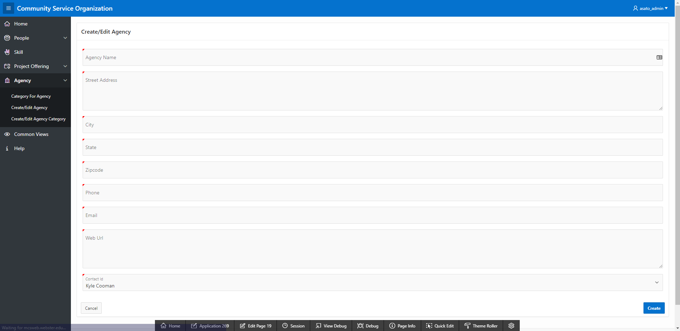

Create/Edit Agency Category (Page 25)

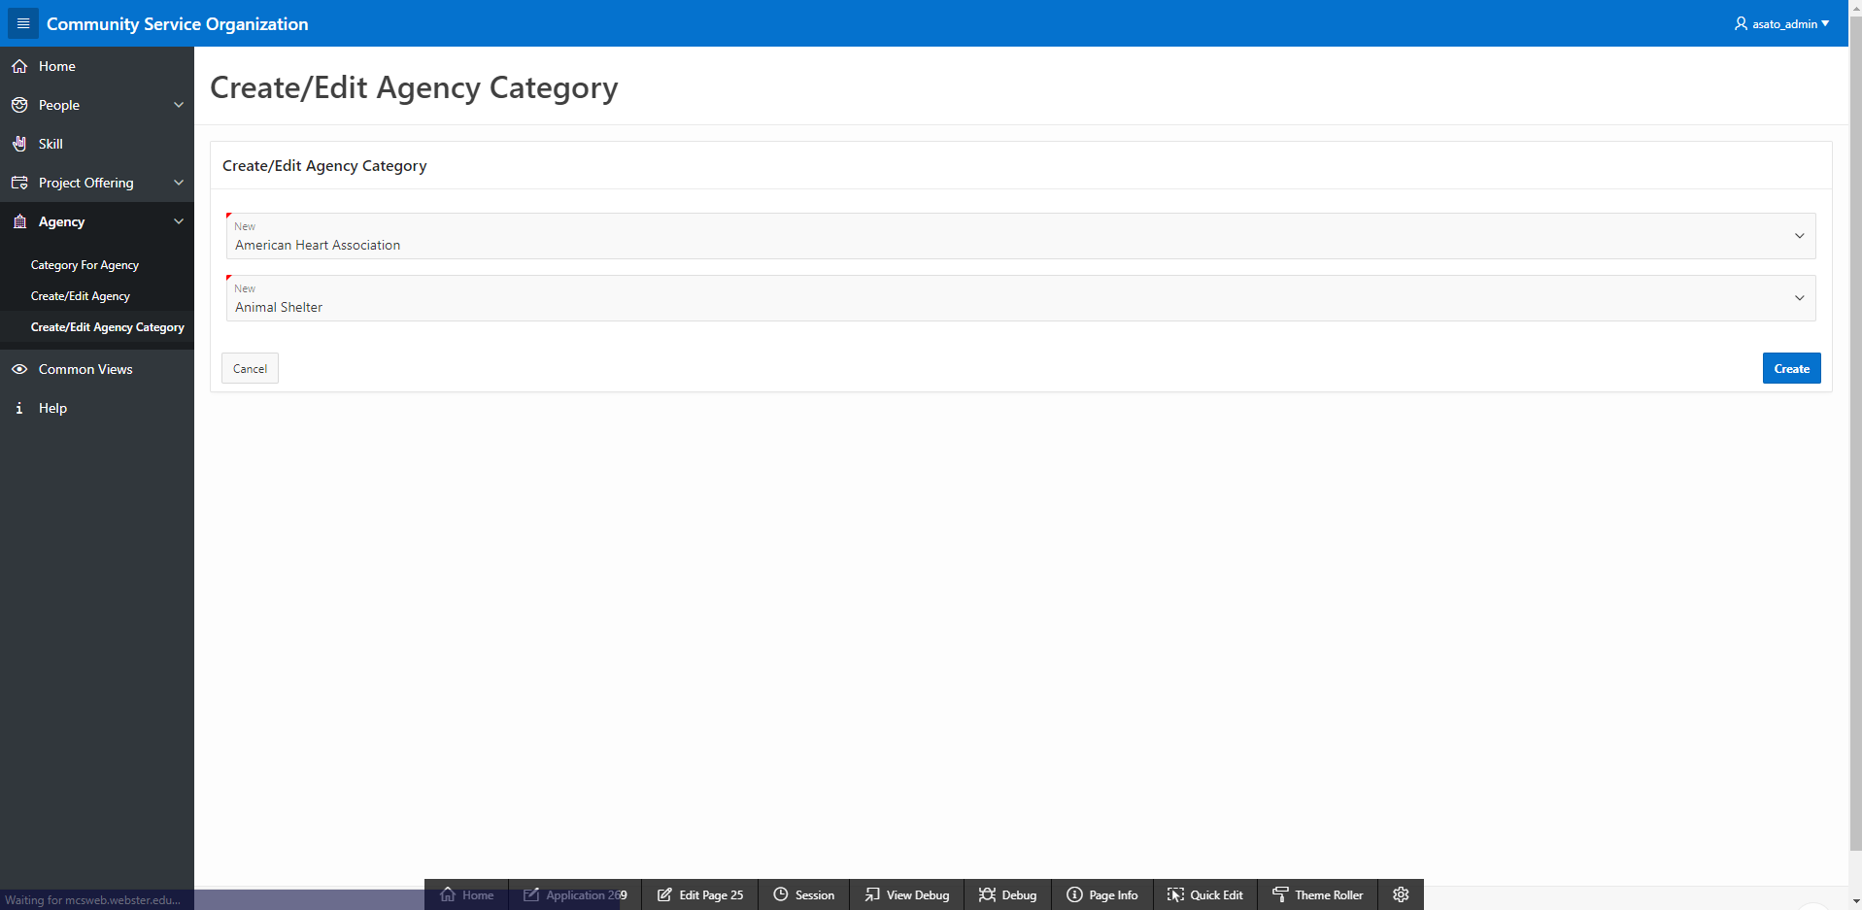

People (Page 2)

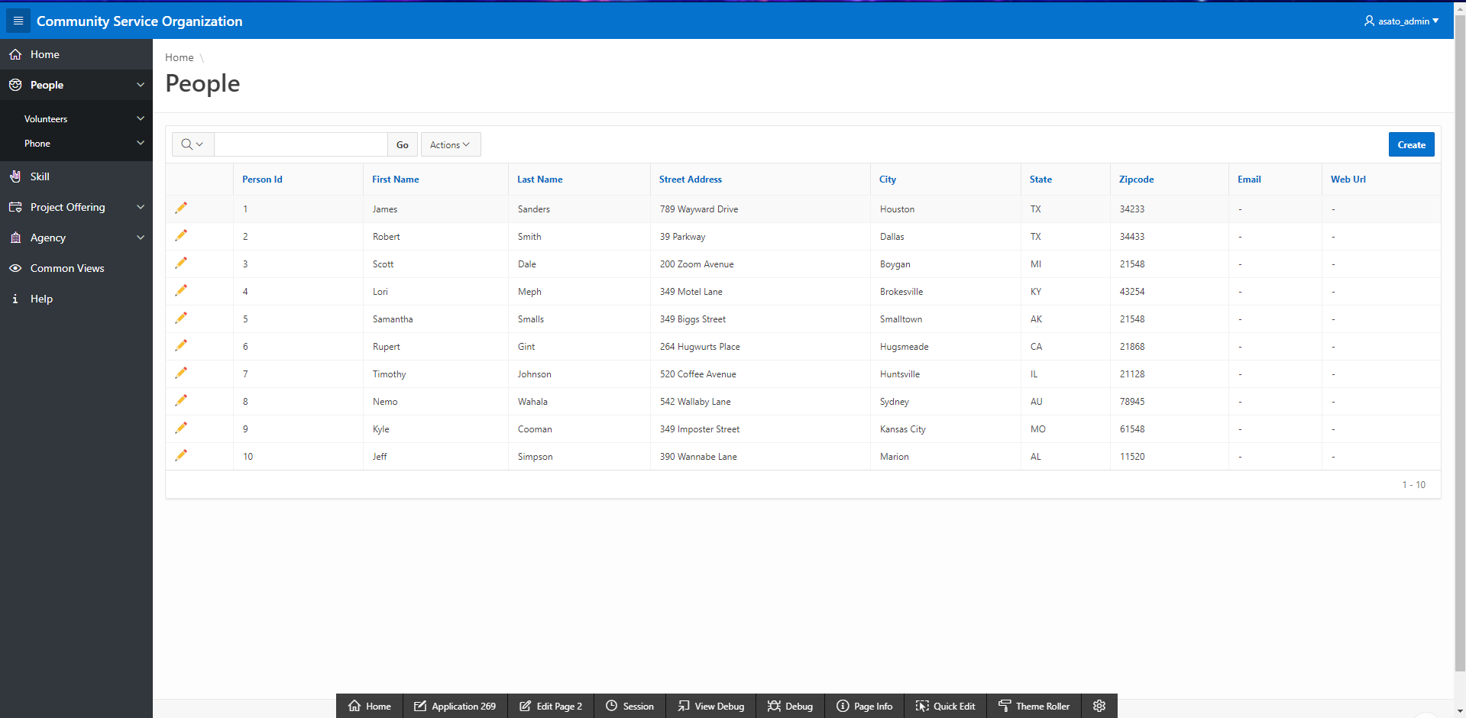

Volunteers (Page 5)

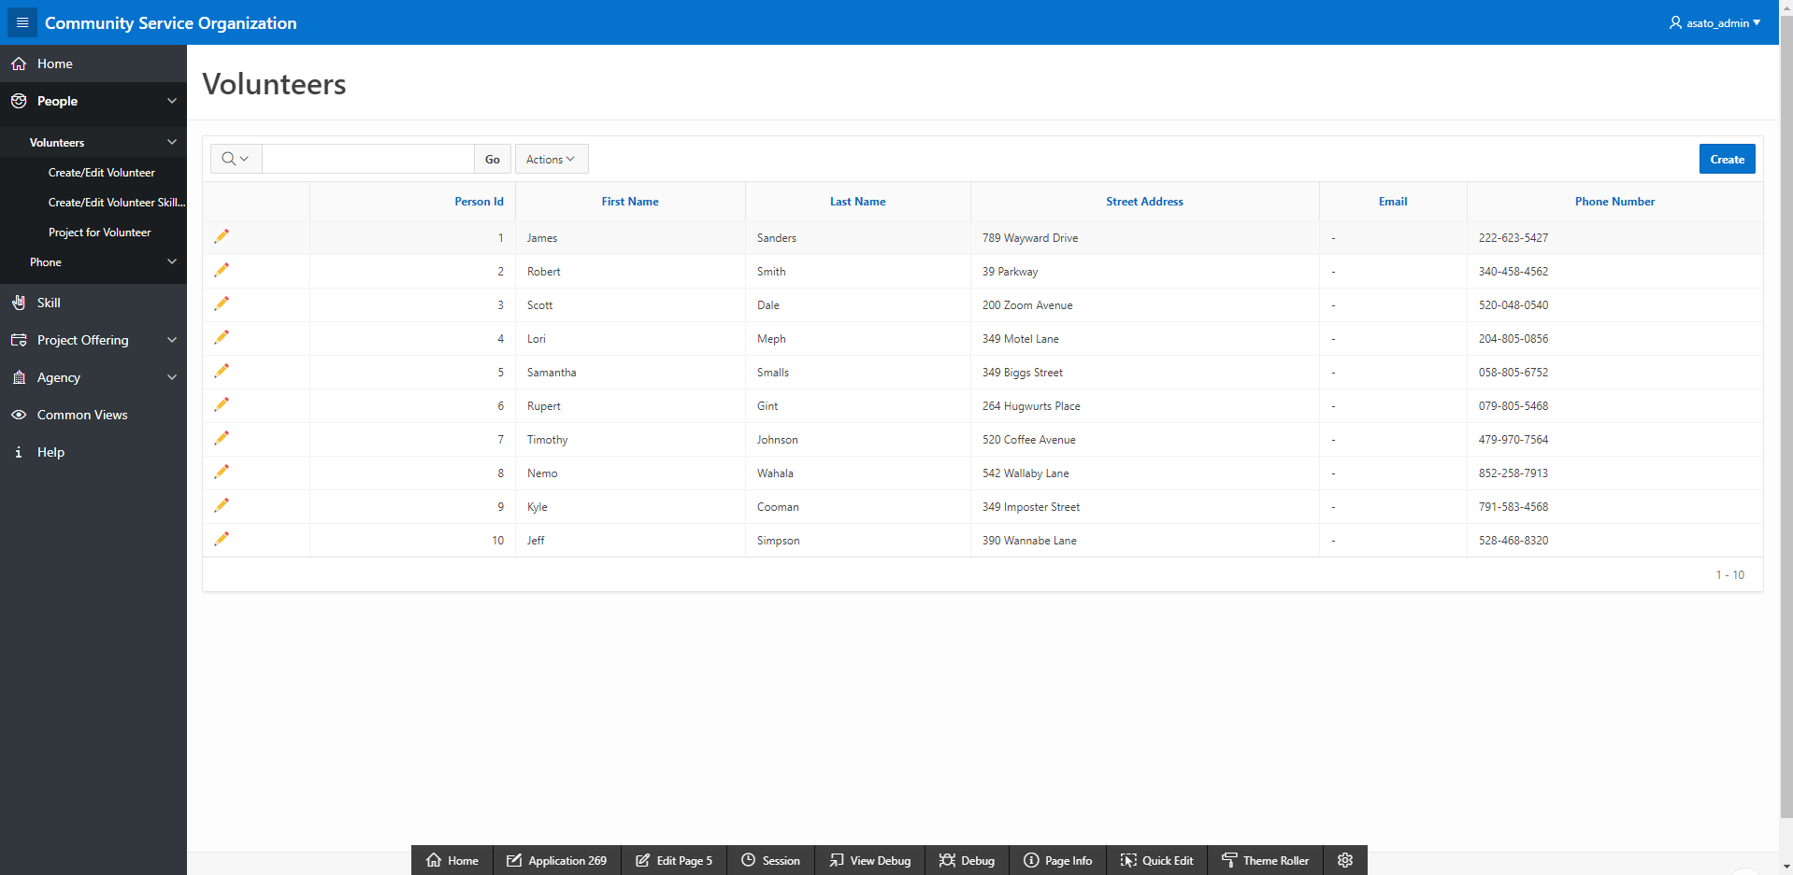

Project for Volunteer (Page 9)

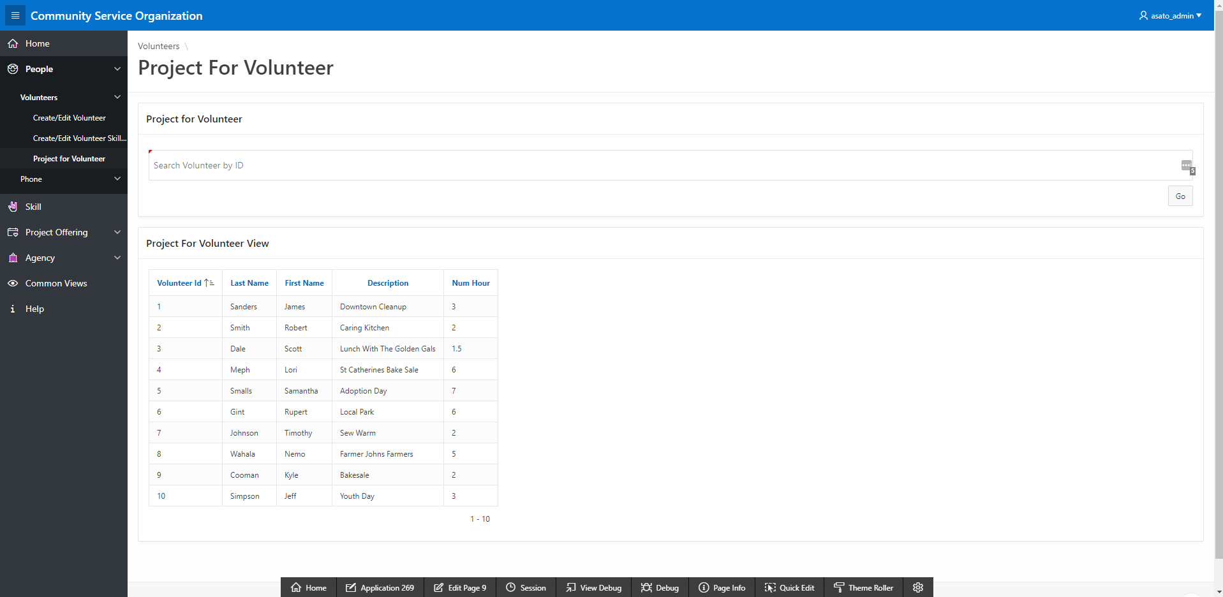

Phone (Page 8)

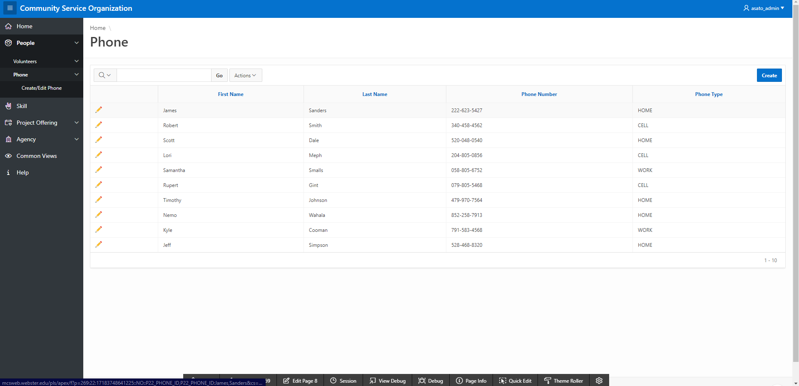

Skill (Page 10)

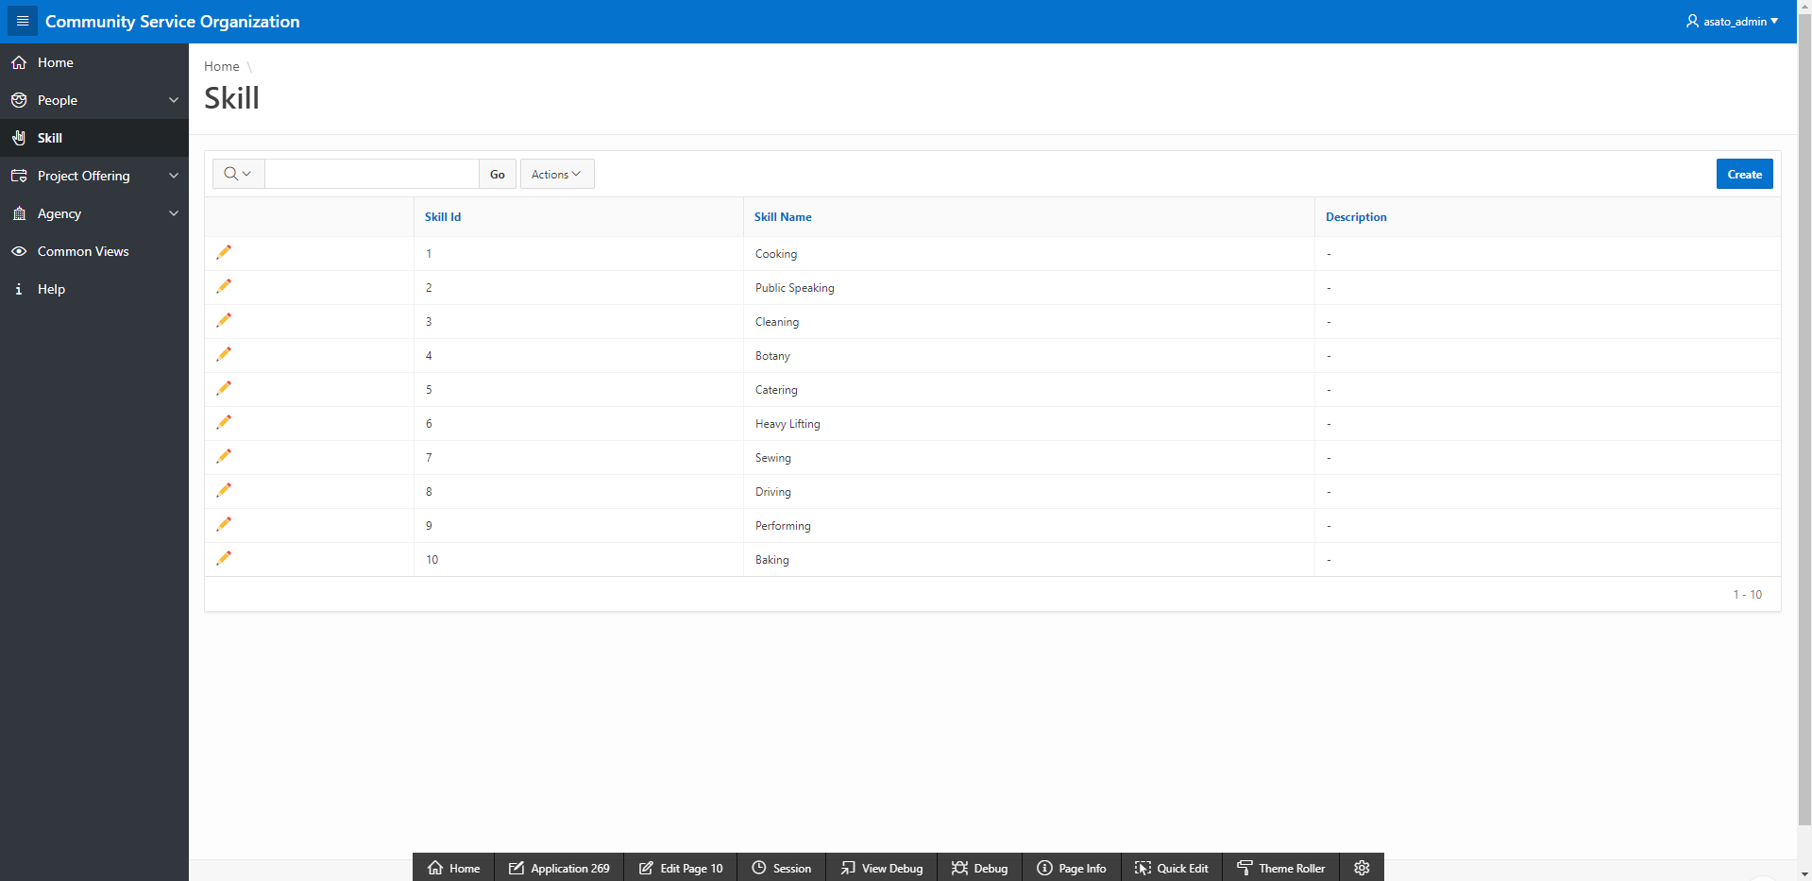

Project Offering (Page 4)

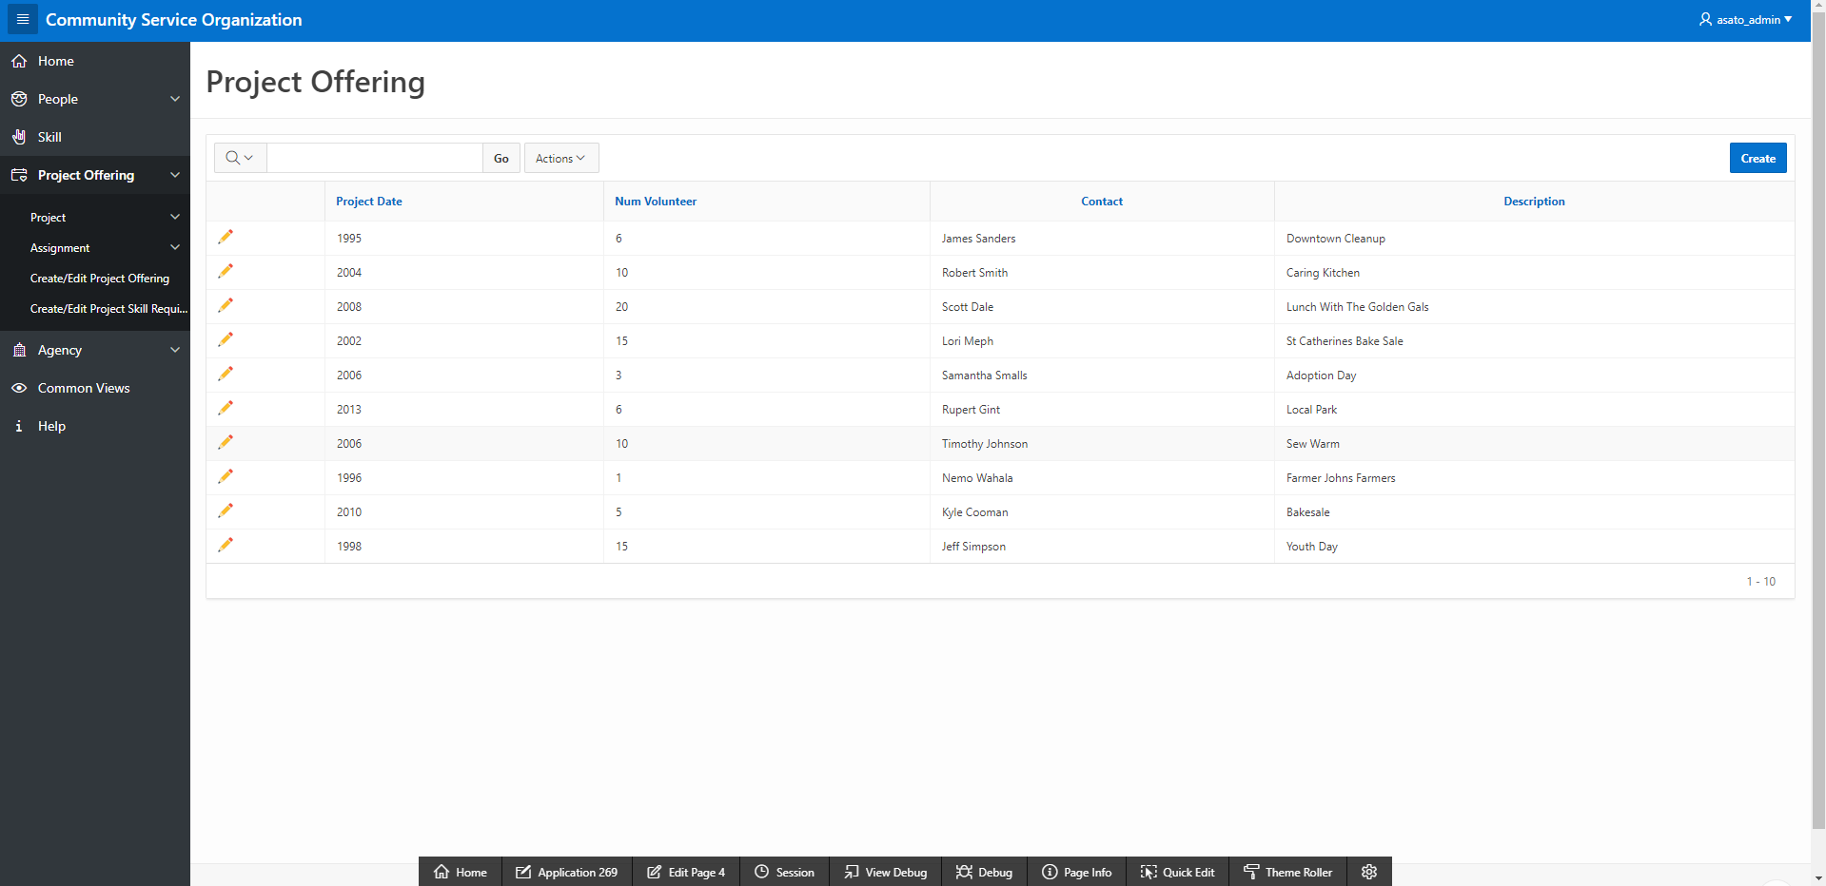

Project (Page 7)

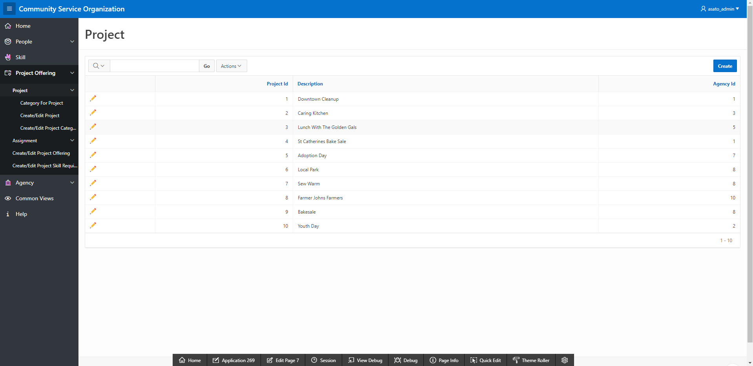

Category for Project (Page 14)

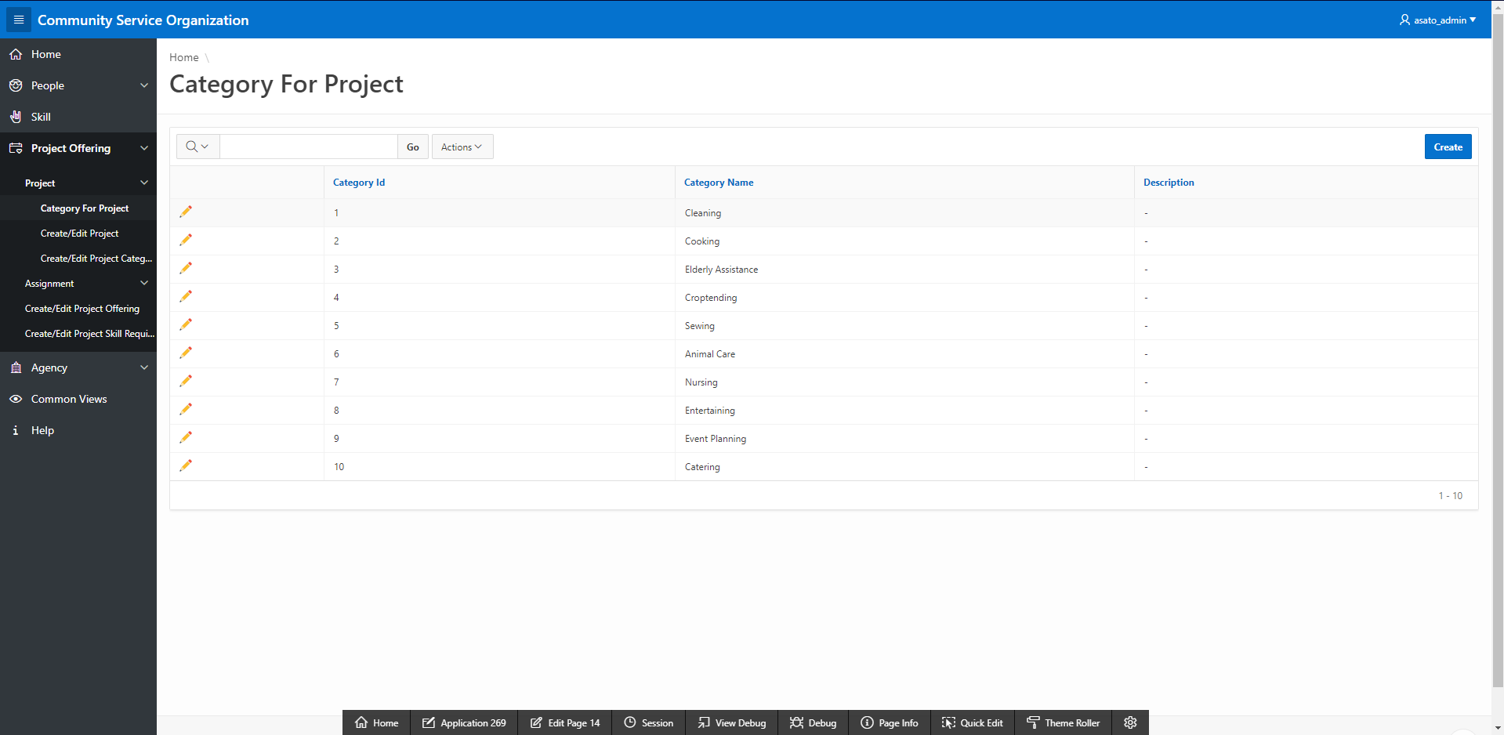

Assignment (Page 16)

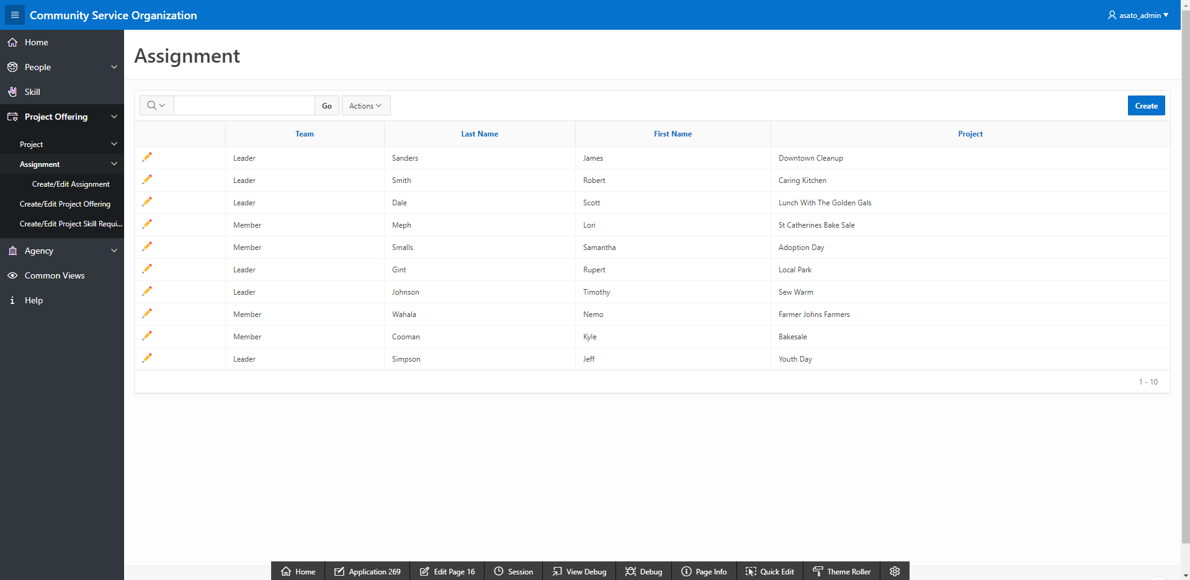

Agency (Page 6)

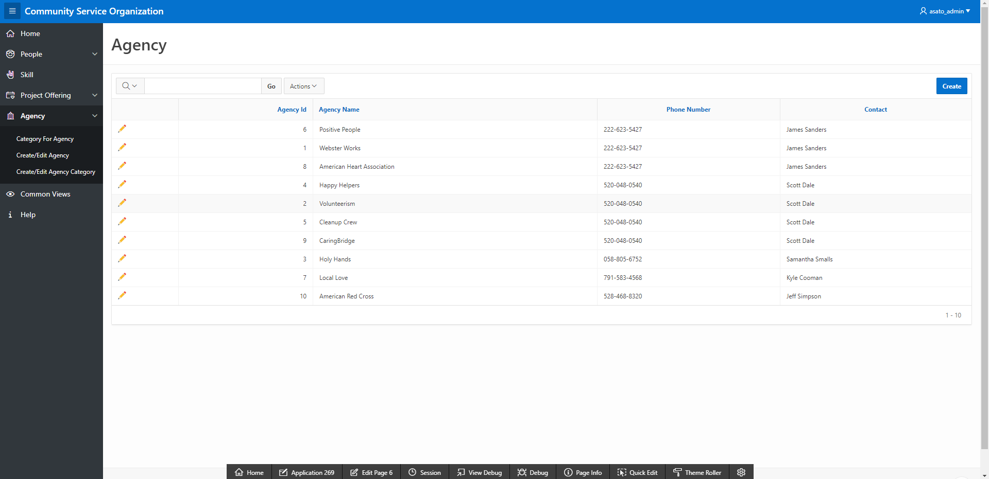

Category for Agency (Page 12)

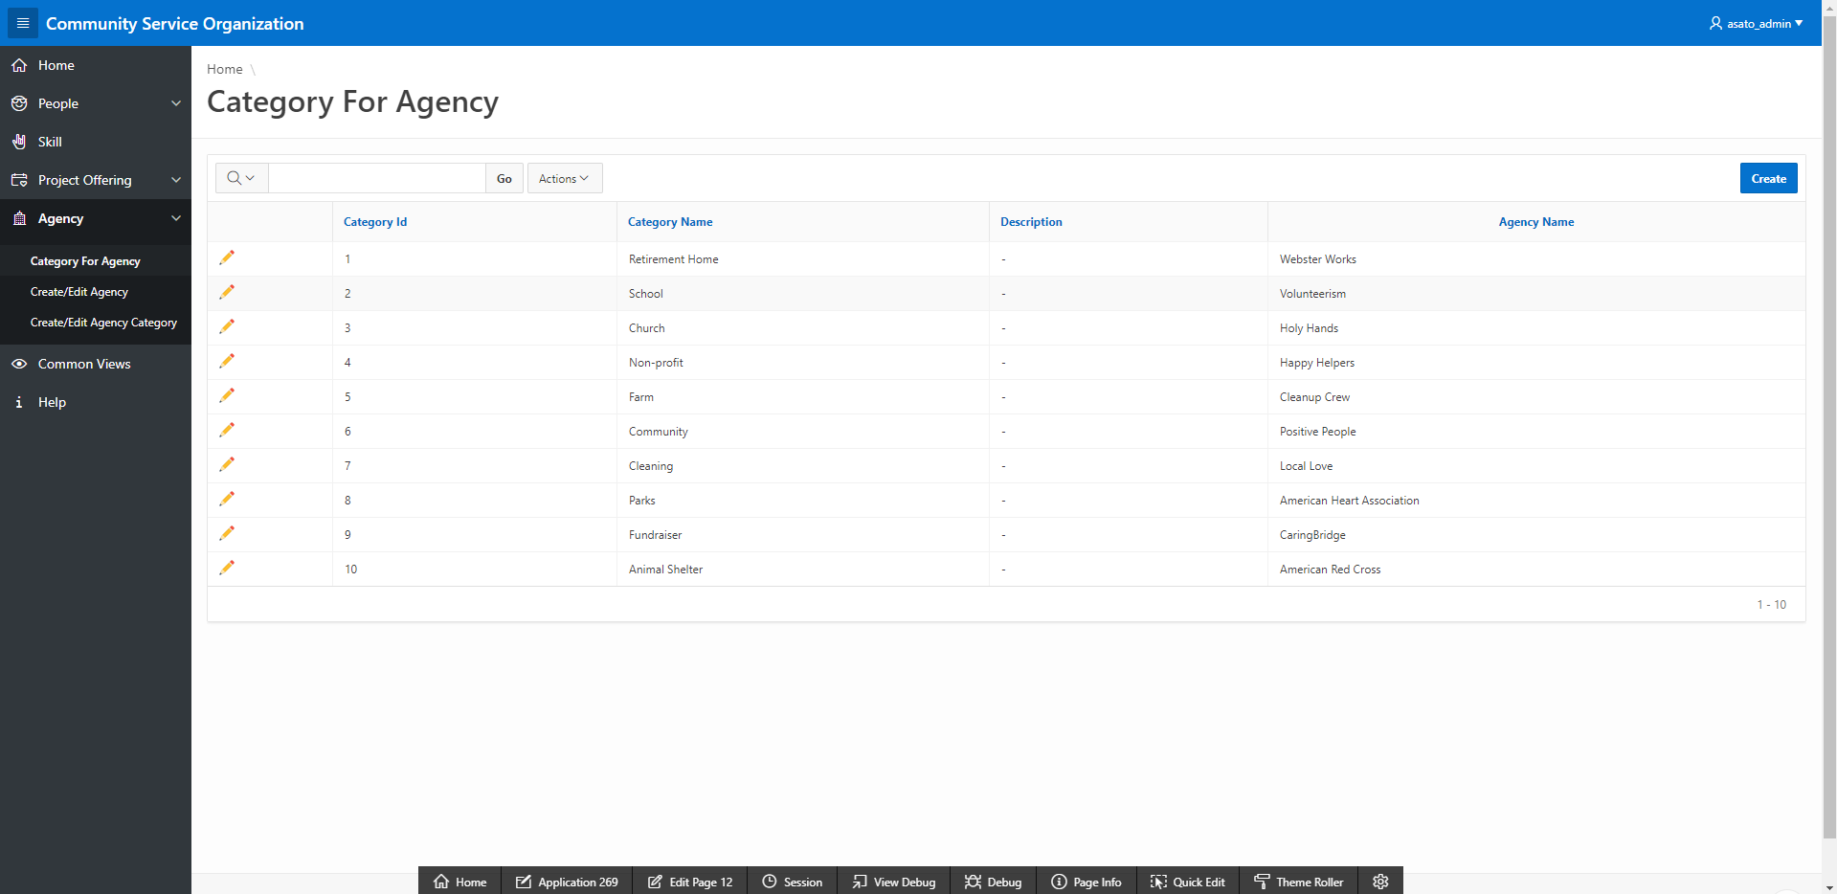

Volunteer Skills (Page 17)

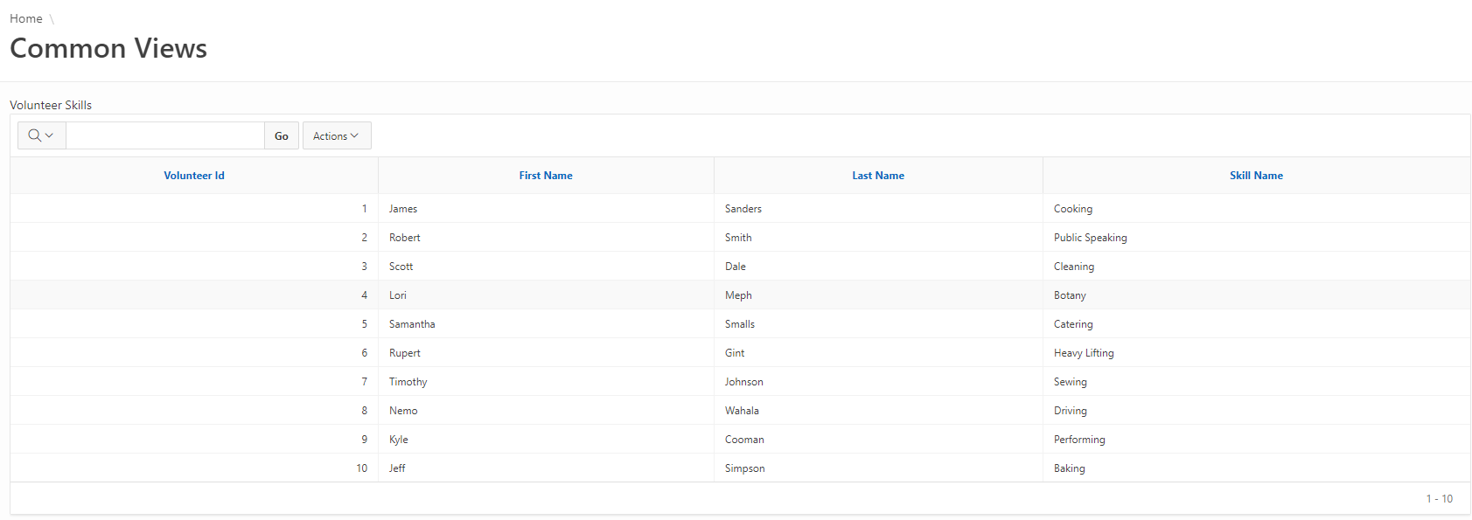

Total Hours Worked by Year (Page 17)

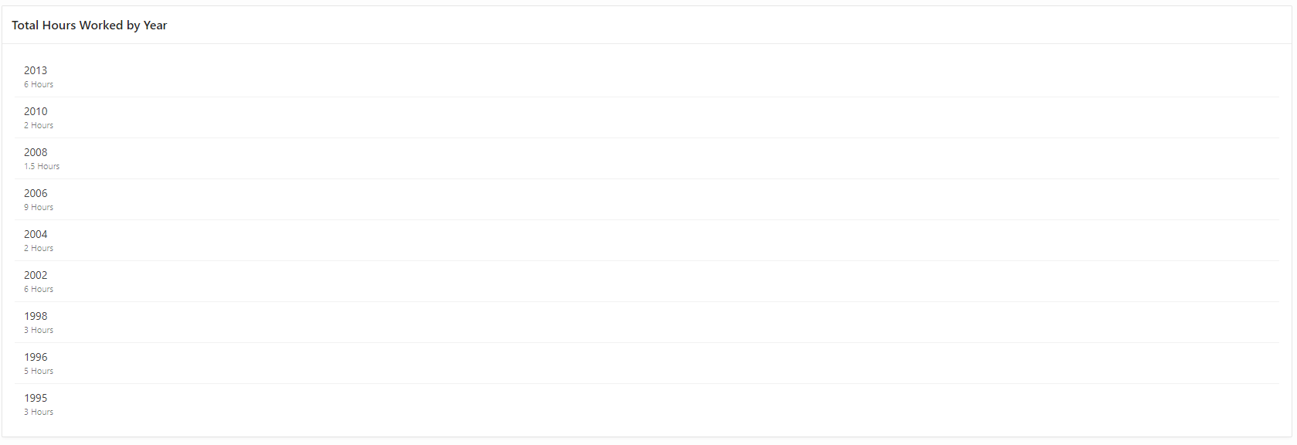

Hours Worked by City (Page 17)

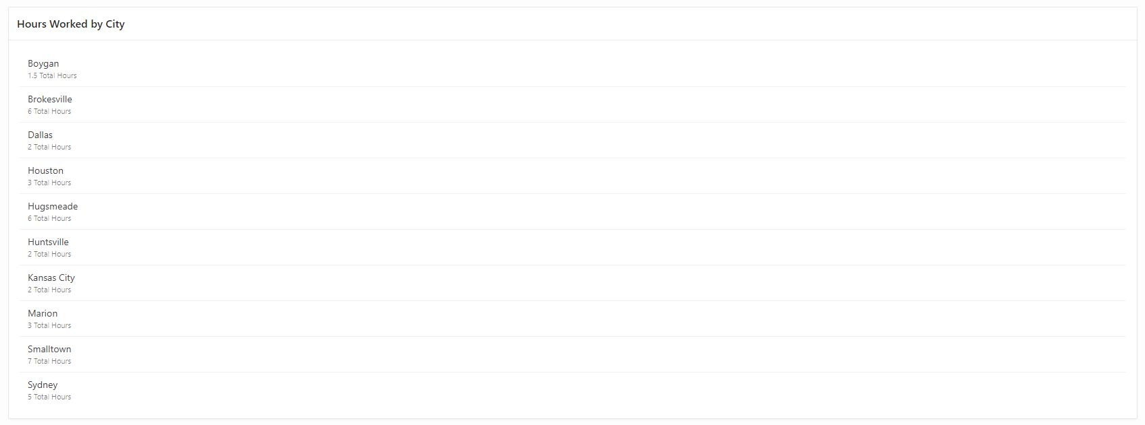

Hours Worked by Volunteer (Page 17)

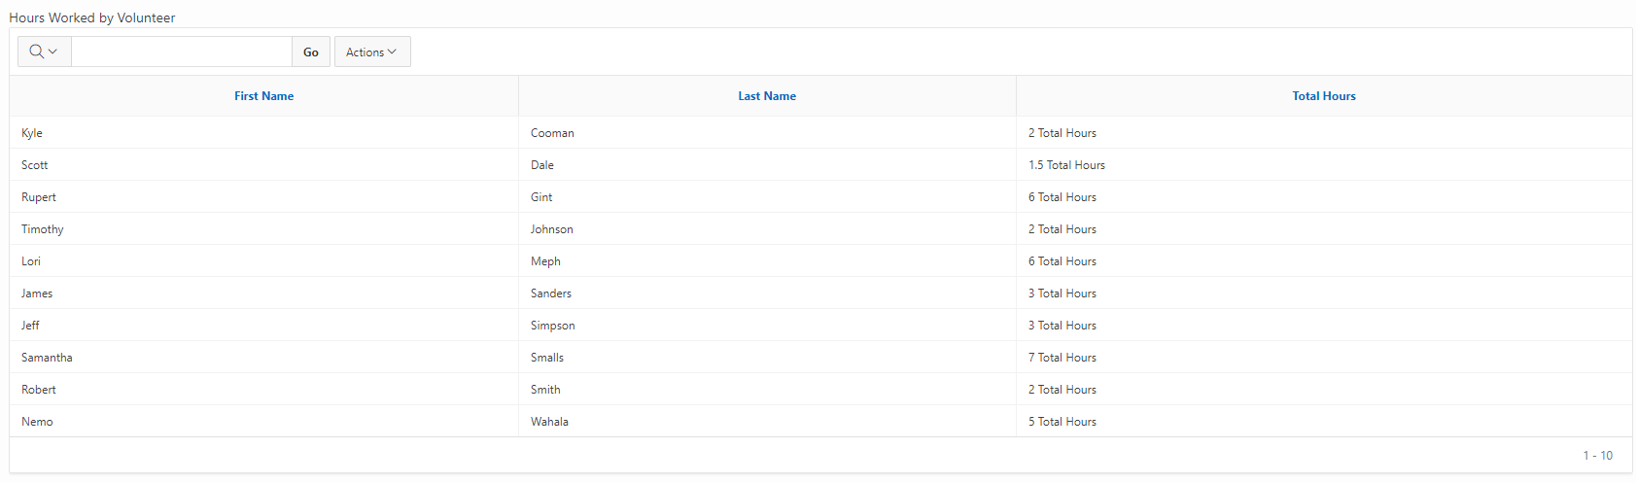

Agency by City (Page 17)

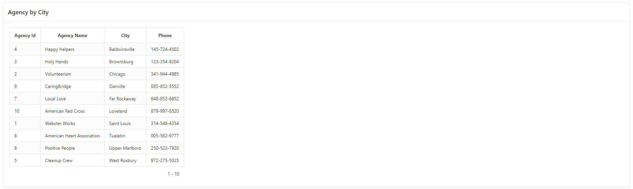

Agency Projects (Page 17)

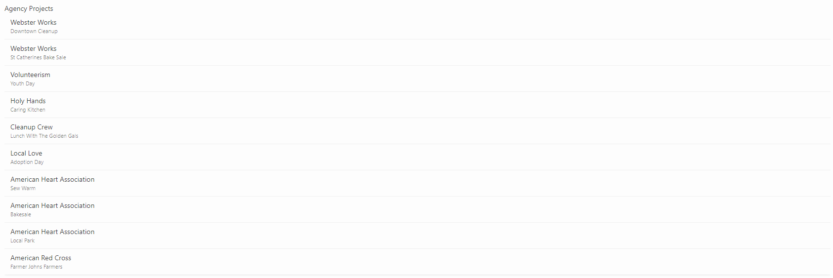

Project Hours (Page 17)

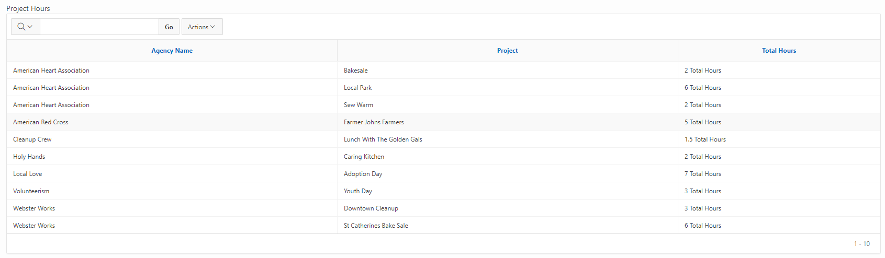

Project Leaders (Page 17)

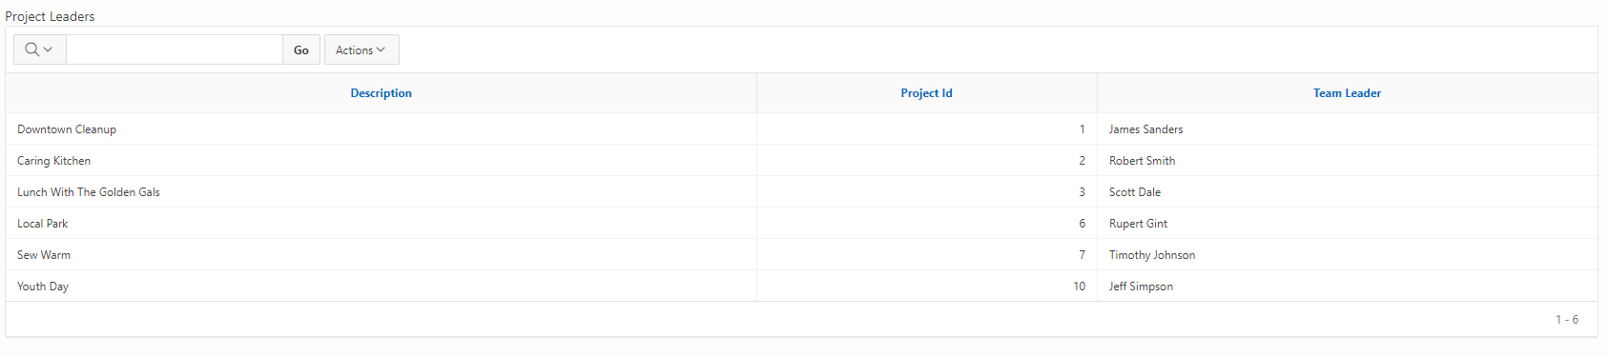

**User Help**

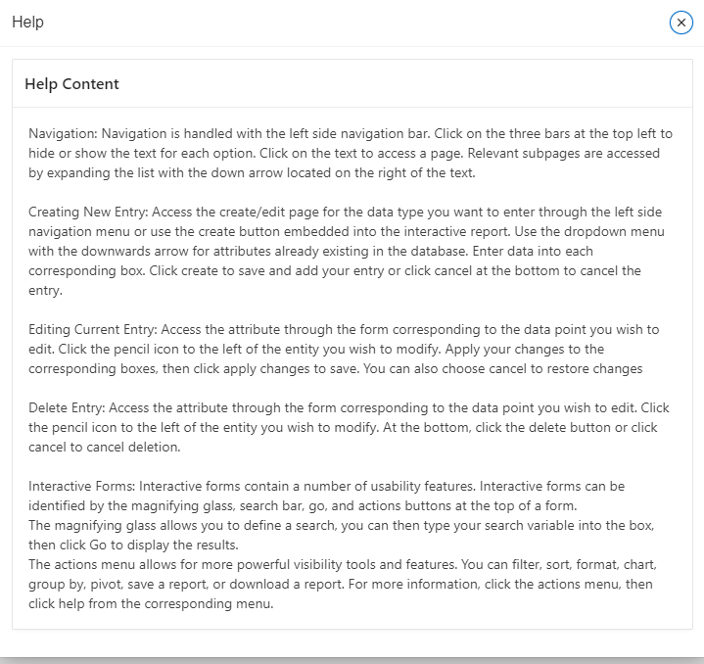

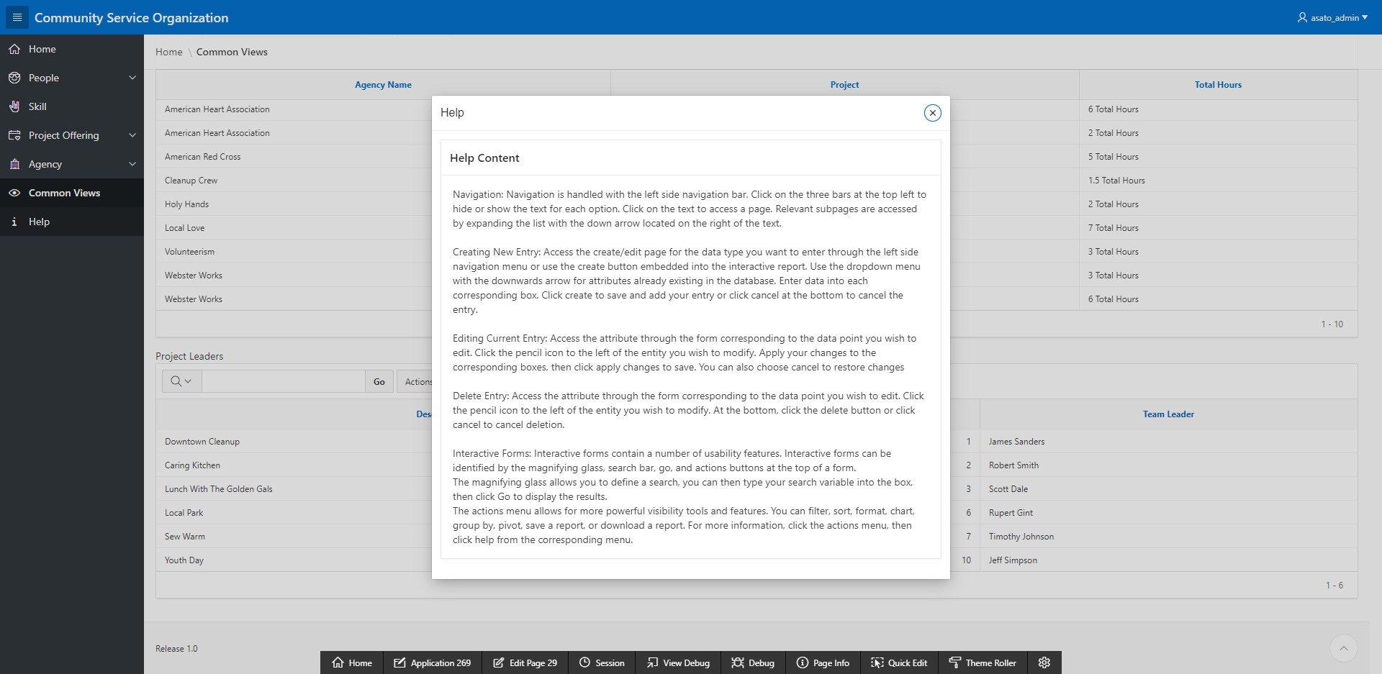

The user help screen is accessed through the navigation bar to the the left. It acts as a pop up window overlay that the user can freely move.

**Data Dictionary**

*People Table*

# **TABLE DESCRIPTION**

This table contains data about people.

|  |  |  |  |  |  |  |  |  |
| --- | --- | --- | --- | --- | --- | --- | --- | --- |
| ATTRIBUTE NAME | CONTENTS | TYPE | LENGTH | FORMAT | RANGE | REQ’D | KEY | REFERENCED  TABLE |
| Person_ID | ID Number | number | 3 | 999 | 1-999 | YES | PK |  |
| first_name | First Name | Varchar2 | 50 | X(50) |  | YES |  |  |
| last_name | Last Name | Varchar2 | 50 | X(50) |  | YES |  |  |
| street_address | Street Address | Varchar2 | 50 | X(50) |  | YES |  |  |
| city | City | Varchar2 | 50 | X(50) |  | YES |  |  |
| state | State | Varchar2 | 50 | X(50) |  | YES |  |  |
| zipcode | Zip Code | Varchar2 | 50 | X(50) |  | YES |  |  |
| email | Email | Varchar2 | 50 | X(50) |  | YES |  |  |
| web_url | Website URL | Varchar2 | 200 | X(200) |  | NO |  |  |

# **OTHER TABLES REFERENCED**

1. Phone – People
   1. One phone is used by one person.
   2. One person uses many phones.
2. Agency - People
   1. One Agency contacts one or many people.
   2. One Person contacts one or many agencies .
3. Project_Offering - People
   1. One project offering contacts one or many people.
   2. One person is contacted by one or many project offerings.
4. Volunteer - People
   1. One volunteer is one person.
   2. One person is one volunteer.

# **SPECIAL RESTRICTIONS**

*Phone Table*

# **TABLE DESCRIPTION**

This table contains data about Phone Numbers.

|  |  |  |  |  |  |  |  |  |
| --- | --- | --- | --- | --- | --- | --- | --- | --- |
| ATTRIBUTE NAME | CONTENTS | TYPE | LENGTH | FORMAT | RANGE | REQ’D | KEY | REFERENCED  TABLE |
| phone_id | ID Number | number | 3 | 999 | 1-999 | YES | PK |  |
| person_id | ID Number | number | 3 | X(3) |  | YES | FK | People |
| phone_type | Type of Phone | Varchar2 | 50 | X(50) |  | NO |  |  |
| phone_number | Phone Number | Varchar2 | 50 | (XXX) XXX - XXXX |  | YES |  |  |

# **OTHER TABLES REFERENCED**

1. Phone – People
   1. One phone is used by one person.
   2. One person uses many phones.

# **SPECIAL RESTRICTIONS**

*Category_for_agency Table*

# **TABLE DESCRIPTION**

This table contains data about Categories for agencies.

|  |  |  |  |  |  |  |  |  |
| --- | --- | --- | --- | --- | --- | --- | --- | --- |
| ATTRIBUTE NAME | CONTENTS | TYPE | LENGTH | FORMAT | RANGE | REQ’D | KEY | REFERENCED  TABLE |
| category_id | ID Number | number | 3 | 999 | 1-999 | YES | PK |  |
| category_name | Category Name | Varchar2 | 50 | X(50) |  | YES |  |  |
| description | Category Description | Varchar2 | 50 | X(50) |  | YES |  |  |

# **OTHER TABLES REFERENCED**

1. Agency_Category – Category_for_agency
   1. One agency category contains one category for agencies.
   2. One category for agencies contains many agency categories.

# **SPECIAL RESTRICTIONS**

*Agency Table*

# **TABLE DESCRIPTION**

This table contains data about agencies.

# 

|  |  |  |  |  |  |  |  |  |
| --- | --- | --- | --- | --- | --- | --- | --- | --- |
| ATTRIBUTE NAME | CONTENTS | TYPE | LENGTH | FORMAT | RANGE | REQ’D | KEY | REFERENCED  TABLE |
| agency_id | ID Number | Number | 3 | 999 | 1-999 | YES | PK |  |
| agency_name | Agency Name | Varchar2 | 50 | X(50) |  |  |  |  |
| street_address | Street Address | Varchar2 | 200 | X(200) |  |  |  |  |
| city | City | Varchar2 | 50 | X(50) |  |  |  |  |
| state | State | Varchar2 | 50 | X(50) |  |  |  |  |
| zipcode | Zipcode | Varchar2 | 50 | X(50) |  |  |  |  |
| phone | Phone Number | Varchar2 | 50 | (XXX) XXX - XXXX |  |  |  |  |
| email | Email Address | Varchar2 | 50 | X(50) |  |  |  |  |
| web_url | Website URL | Varchar2 | 200 | X(200) |  |  |  |  |
| contact_id | ID Number | Number | 3 | 999 |  | YES | FK | People |

# **OTHER TABLES REFERENCED**

1. Agency - People
   1. One Agency contacts one or many people.
   2. One Person contacts one or many agencies .
2. Project - Agency
   1. One project is owned by one or many agencies.
   2. One agency owns many projects.

# **SPECIAL RESTRICTIONS**

*Agency_Category Table*

# **TABLE DESCRIPTION**

This table contains data about categories for agencies.

|  |  |  |  |  |  |  |  |  |
| --- | --- | --- | --- | --- | --- | --- | --- | --- |
| ATTRIBUTE NAME | CONTENTS | TYPE | LENGTH | FORMAT | RANGE | REQ’D | KEY | REFERENCED  TABLE |
| agency_id | ID Number | number | 3 | 999 | 1-999 | YES | CK | Agency |
| category_id | ID Name | number | 3 | 999 | 1-999 | YES | CK | Category |

# **OTHER TABLES REFERENCED**

1. Agency_Category - agency
   1. One agency category belongs to one agency.
   2. One agency belongs to many agency categories.
2. Agency_Category – Category_for_agency
   1. One agency category contains one category for agencies.
   2. One category for agencies contains many agency categories.

# **SPECIAL RESTRICTIONS**

*Category_for_project Table*

# **TABLE DESCRIPTION**

This table contains data about categories for projects.

|  |  |  |  |  |  |  |  |  |
| --- | --- | --- | --- | --- | --- | --- | --- | --- |
| ATTRIBUTE NAME | CONTENTS | TYPE | LENGTH | FORMAT | RANGE | REQ’D | KEY | REFERENCED  TABLE |
| category_id | ID Number | Number | 3 | 999 | 1-999 | YES | PK |  |
| category_name | Category Name | Varchar2 | 50 | X(50) |  | YES |  |  |
| description | Description of Category | Varchar2 | 50 | X(50) |  | YES |  |  |

# **OTHER TABLES REFERENCED**

1. Project_Category – Category_For_Project
   1. One project category contains one category for project.
   2. One category for project contains many project categories.

# **SPECIAL RESTRICTIONS**

*Project Table*

# **TABLE DESCRIPTION**

This table contains data about projects.

|  |  |  |  |  |  |  |  |  |
| --- | --- | --- | --- | --- | --- | --- | --- | --- |
| ATTRIBUTE NAME | CONTENTS | TYPE | LENGTH | FORMAT | RANGE | REQ’D | KEY | REFERENCED  TABLE |
| project_id | ID Number | Number | 3 | 999 | 1-999 | YES | PK |  |
| description | Description | Varchar2 | 50 | X(50) |  | YES |  |  |
| agency_id | ID Number | Number | 3 | X(3) |  | YES | FK | agency |

# **OTHER TABLES REFERENCED**

1. Project - Agency
   1. One project is owned by one or many agencies.
   2. One agency owns many projects.
2. Project_Offering - Project
   1. One project offering is offered by one project.
   2. One project offers many project offerings.
3. Project_Category - Project
   1. One project category belongs to one project.
   2. One project belongs to many project categories.
4. Project_Skill_Requirement – Project
   1. One project skill requirement is required by one project.
   2. One project requires many project skill requirements.

# **SPECIAL RESTRICTIONS**

*Project_offering Table*

# **TABLE DESCRIPTION**

This table contains data about project offerings.

|  |  |  |  |  |  |  |  |  |
| --- | --- | --- | --- | --- | --- | --- | --- | --- |
| ATTRIBUTE NAME | CONTENTS | TYPE | LENGTH | FORMAT | RANGE | REQ’D | KEY | REFERENCED  TABLE |
| project_offering_id | ID Number | Number | 3 | 999 | 1-999 | YES | PK |  |
| project_id | ID Number | Number | 3 | X(3) | 1-999 | YES | FK | project |
| project_date | Project Date | Varchar2 | 50 | MM/DD/YYYY |  | YES |  |  |
| contact_id | ID Number | Number | 3 | 999 | 1-999 | YES | FK | people |
| num_volunteer | Number of Volunteers | Varchar2 | 50 | X(50) |  | YES |  |  |
| num_hour | Number of Hours | Varchar2 | 50 | X(50) |  | YES |  |  |

# **OTHER TABLES REFERENCED**

1. Project_Offering - Project
   1. One project offering is offered by one project.
   2. One project offers many project offerings.
2. Project_Offering - People
   1. One project offering contacts one or many people.
   2. One person is contacted by one or many project offerings.
3. Assignment – Project_Offering
   1. One assignment takes one or many project offerings.
   2. One project offering is taken by many assignments.

# **SPECIAL RESTRICTIONS**

*Project_category Table*

# **TABLE DESCRIPTION**

This table contains data about categories for projects.

|  |  |  |  |  |  |  |  |  |
| --- | --- | --- | --- | --- | --- | --- | --- | --- |
| ATTRIBUTE NAME | CONTENTS | TYPE | LENGTH | FORMAT | RANGE | REQ’D | KEY | REFERENCED  TABLE |
| project_id | ID Number | number | 3 | 999 | 1-999 | YES | CK | project |
| category_id | ID Number | Number | 3 | 999 | 1-999 | YES | CK | category_for_project |

# **OTHER TABLES REFERENCED**

1. Project_Category - Project
   1. One project category belongs to one project.
   2. One project belongs to many project categories.
2. Project_Category – Category_For_Project
   1. One project category contains one category for project.
   2. One category for project contains many project categories.

# **SPECIAL RESTRICTIONS**

*Volunteer Table*

# **TABLE DESCRIPTION**

This table contains data about volunteers.

|  |  |  |  |  |  |  |  |  |
| --- | --- | --- | --- | --- | --- | --- | --- | --- |
| ATTRIBUTE NAME | CONTENTS | TYPE | LENGTH | FORMAT | RANGE | REQ’D | KEY | REFERENCED  TABLE |
| volunteer_id | ID Number | Number | 3 | 999 | 1-999 | YES | PK |  |
| person_id | ID Number | Number | 3 | 999 | 1-999 | YES | FK | People |

# **OTHER TABLES REFERENCED**

1. Volunteer - People
   1. One volunteer is one person.
   2. One person is one volunteer.
2. Assignment - Volunteer
   1. One assignment is joined by one or many volunteers.
   2. One volunteer joins many assignments.
3. Volunteer_Skillset - Volunteer
   1. One volunteer skillset has one volunteer.
   2. One volunteer has many volunteer skillsets.

# **SPECIAL RESTRICTIONS**

*Assignment Table*

# **TABLE DESCRIPTION**

This table contains data about assignments.

|  |  |  |  |  |  |  |  |  |
| --- | --- | --- | --- | --- | --- | --- | --- | --- |
| ATTRIBUTE NAME | CONTENTS | TYPE | LENGTH | FORMAT | RANGE | REQ’D | KEY | REFERENCED  TABLE |
| assignment_id | ID Number | Number | 3 | 999 | 1-999 | YES | PK |  |
| project_offering_id | ID Number | Number | 3 | 999 | 1-999 | YES | FK | project_offering |
| volunteer_id | ID Number | Number | 3 | 999 | 1-999 | YES | FK | volunteer |
| is_leader | Leader or Not | Varchar2 | 10 | X(15) |  | YES |  |  |

# **OTHER TABLES REFERENCED**

1. Assignment – Project_Offering
   1. One assignment takes one or many project offerings.
   2. One project offering is taken by many assignments.
2. Assignment - Volunteer
   1. One assignment is joined by one or many volunteers.
   2. One volunteer joins many assignments.

# **SPECIAL RESTRICTIONS**

*Skill Table*

# **TABLE DESCRIPTION**

This table contains data about skills.

|  |  |  |  |  |  |  |  |  |
| --- | --- | --- | --- | --- | --- | --- | --- | --- |
| ATTRIBUTE NAME | CONTENTS | TYPE | LENGTH | FORMAT | RANGE | REQ’D | KEY | REFERENCED  TABLE |
| skill_id_number | ID Number | Number | 3 | 999 | 1-999 | YES | PK |  |
| skill_name | Skill Name | Varchar2 | 50 | X(50) |  | YES |  |  |
| description | Skill Description | Varchar2 | 50 | X(50) |  | YES |  |  |

# **OTHER TABLES REFERENCED**

1. Volunteer_Skillset - Skill
   1. One volunteer skillset masters one skill.
   2. One skill is mastered by many volunteer skillset.
2. Project_Skill_Requirement – Skill
   1. One project skill requirement requires one skill.
   2. One skill is required by many project skill requirements.

# **SPECIAL RESTRICTIONS**

*Volunteer_skillset Table*

# **TABLE DESCRIPTION**

This table contains data about volunteer’s skillsets.

|  |  |  |  |  |  |  |  |  |
| --- | --- | --- | --- | --- | --- | --- | --- | --- |
| ATTRIBUTE NAME | CONTENTS | TYPE | LENGTH | FORMAT | RANGE | REQ’D | KEY | REFERENCED  TABLE |
| volunteer_id | ID Number | Number | 3 | 999 | 1-999 | YES | CK | volunteer |
| skill_id | ID Number | Number | 3 | 999 | 1-999 | YES | CK | skill |

# **OTHER TABLES REFERENCED**

1. Volunteer_Skillset - Volunteer
   1. One volunteer skillset has one volunteer.
   2. One volunteer has many volunteer skillsets.
2. Volunteer_Skillset - Skill
   1. One volunteer skillset masters one skill.
   2. One skill is mastered by many volunteer skillset.

# **SPECIAL RESTRICTIONS**

*Project_skill_requirement Table*

# **TABLE DESCRIPTION**

This table contains data about skill requirements for a project.

|  |  |  |  |  |  |  |  |  |
| --- | --- | --- | --- | --- | --- | --- | --- | --- |
| ATTRIBUTE NAME | CONTENTS | TYPE | LENGTH | FORMAT | RANGE | REQ’D | KEY | REFERENCED  TABLE |
| project_id_number | ID Number | Number | 3 | 999 | 1-999 | YES | CK | project |
| skill_id | ID Number | Number | 3 | 999 | 1-999 | YES | CK | skill |

# **OTHER TABLES REFERENCED**

1. Project_Skill_Requirement – Project
   1. One project skill requirement is required by one project.
   2. One project requires many project skill requirements.
2. Project_Skill_Requirement – Skill
   1. One project skill requirement requires one skill.
   2. One skill is required by many project skill requirements.

# **SPECIAL RESTRICTIONS**

**Crow’s Foot Notation Diagram**

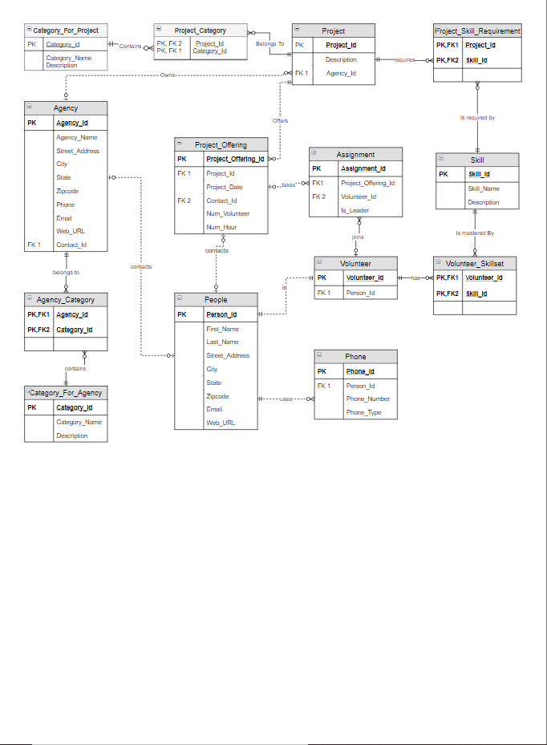

**Chen Notation Diagram**

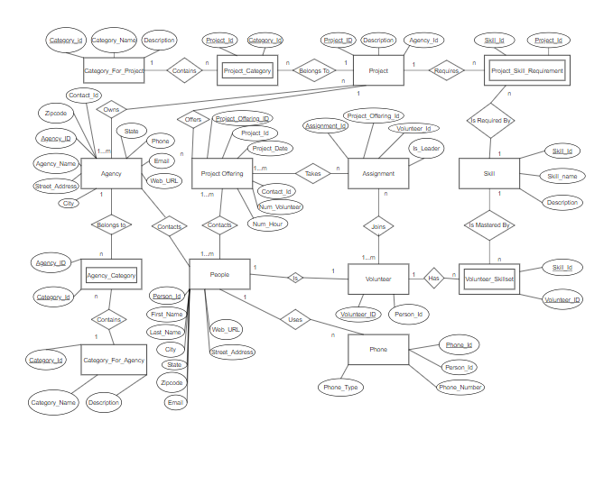

|  |  |  |  |
| --- | --- | --- | --- |
| Object Type | **TABLE** | Object | **PEOPLE** |

|  |  |  |  |  |  |  |  |  |  |
| --- | --- | --- | --- | --- | --- | --- | --- | --- | --- |
| **Table** | **Column** | **Data Type** | **Length** | **Precision** | **Scale** | **Primary Key** | **Nullable** | **Default** | **Comment** |
| PEOPLE | PERSON_ID | NUMBER | - | 3 | 0 | 1 | - | - | - |
|  | FIRST_NAME | VARCHAR2 | 50 | - | - | - | nullable | - | - |
|  | LAST_NAME | VARCHAR2 | 50 | - | - | - | nullable | - | - |
|  | STREET_ADDRESS | VARCHAR2 | 200 | - | - | - | nullable | - | - |

|  |  |  |  |  |  |  |  |  |
| --- | --- | --- | --- | --- | --- | --- | --- | --- |
| **PERSON_ID** | **FIRST_NAME** | **LAST_NAME** | **STREET_ADDRESS** | **CITY** | **STATE** | **ZIPCODE** | **EMAIL** | **WEB_URL** |
| 1 | James | Sanders | 789 Wayward Drive | Houston | TX | 34233 | - | - |
| 2 | Robert | Smith | 39 Parkway | Dallas | TX | 34433 | - | - |
| 3 | Scott | Dale | 200 Zoom Avenue | Boygan | MI | 21548 | - | - |
| 4 | Lori | Meph | 349 Motel Lane | Brokesville | KY | 43254 | - | - |
| 5 | Samantha | Smalls | 349 Biggs Street | Smalltown | AK | 21548 | - | - |
| 6 | Rupert | Gint | 264 Hugwurts Place | Hugsmeade | CA | 21868 | - | - |
| 7 | Timothy | Johnson | 520 Coffee Avenue | Huntsville | IL | 21128 | - | - |
| 8 | Nemo | Wahala | 542 Wallaby Lane | Sydney | AU | 78945 | - | - |
| 9 | Kyle | Cooman | 349 Imposter Street | Kansas City | MO | 61548 | - | - |
| 10 | Jeff | Simpson | 390 Wannabe Lane | Marion | AL | 11520 | - | - |

|  |  |  |  |
| --- | --- | --- | --- |
| Object Type | **TABLE** | Object | **PHONE** |

|  |  |  |  |  |  |  |  |  |  |
| --- | --- | --- | --- | --- | --- | --- | --- | --- | --- |
| **Table** | **Column** | **Data Type** | **Length** | **Precision** | **Scale** | **Primary Key** | **Nullable** | **Default** | **Comment** |
| PHONE | PHONE_ID | NUMBER | - | 3 | 0 | 1 | - | - | - |
|  | PERSON_ID | NUMBER | - | 3 | 0 | - | nullable | - | - |
|  | PHONE_TYPE | VARCHAR2 | 50 | - | - | - | nullable | - | - |
|  | PHONE_NUMBER | VARCHAR2 | 50 | - | - | - | nullable | - | - |

|  |  |  |  |
| --- | --- | --- | --- |
| **PHONE_ID** | **PERSON_ID** | **PHONE_TYPE** | **PHONE_NUMBER** |
| 1 | 1 | HOME | 222-623-5427 |
| 2 | 2 | CELL | 340-458-4562 |
| 3 | 3 | HOME | 520-048-0540 |
| 4 | 4 | CELL | 204-805-0856 |
| 5 | 5 | WORK | 058-805-6752 |
| 6 | 6 | CELL | 079-805-5468 |
| 7 | 7 | HOME | 479-970-7564 |
| 8 | 8 | HOME | 852-258-7913 |
| 9 | 9 | WORK | 791-583-4568 |
| 10 | 10 | HOME | 528-468-8320 |

|  |  |  |  |
| --- | --- | --- | --- |
| Object Type | **TABLE** | Object | **CATEGORY_FOR_AGENCY** |

|  |  |  |  |  |  |  |  |  |  |
| --- | --- | --- | --- | --- | --- | --- | --- | --- | --- |
| **Table** | **Column** | **Data Type** | **Length** | **Precision** | **Scale** | **Primary Key** | **Nullable** | **Default** | **Comment** |
| CATEGORY_FOR_AGENCY | CATEGORY_ID | NUMBER | - | 3 | 0 | 1 | - | - | - |
|  | CATEGORY_NAME | VARCHAR2 | 50 | - | - | - | nullable | - | - |
|  | DESCRIPTION | VARCHAR2 | 50 | - | - | - | nullable | - | - |

|  |  |  |
| --- | --- | --- |
| **CATEGORY_ID** | **CATEGORY_NAME** | **DESCRIPTION** |
| 1 | Retirement Home | - |
| 2 | School | - |
| 3 | Church | - |
| 4 | Non-profit | - |
| 5 | Farm | - |
| 6 | Community | - |
| 7 | Cleaning | - |
| 8 | Parks | - |
| 9 | Fundraiser | - |
| 10 | Animal Shelter | - |

|  |  |  |  |
| --- | --- | --- | --- |
| Object Type | **TABLE** | Object | **AGENCY** |

|  |  |  |  |  |  |  |  |  |  |
| --- | --- | --- | --- | --- | --- | --- | --- | --- | --- |
| **Table** | **Column** | **Data Type** | **Length** | **Precision** | **Scale** | **Primary Key** | **Nullable** | **Default** | **Comment** |
| AGENCY | AGENCY_ID | NUMBER | - | 3 | 0 | 1 | - | - | - |
|  | AGENCY_NAME | VARCHAR2 | 50 | - | - | - | nullable | - | - |
|  | STREET_ADDRESS | VARCHAR2 | 200 | - | - | - | nullable | - | - |
|  | CITY | VARCHAR2 | 50 | - | - | - | nullable | - | - |
|  | STATE | VARCHAR2 | 50 | - | - | - | nullable | - | - |
|  | ZIPCODE | VARCHAR2 | 50 | - | - | - | nullable | - | - |
|  | PHONE | VARCHAR2 | 50 | - | - | - | nullable | - | - |
|  | EMAIL | VARCHAR2 | 50 | - | - | - | nullable | - | - |
|  | WEB_URL | VARCHAR2 | 200 | - | - | - | nullable | - | - |
|  | CONTACT_ID | NUMBER | - | 3 | 0 | - | nullable | - | - |

|  |  |  |  |  |  |  |  |  |  |
| --- | --- | --- | --- | --- | --- | --- | --- | --- | --- |
| **AGENCY_ID** | **AGENCY_NAME** | **STREET_ADDRESS** | **CITY** | **STATE** | **ZIPCODE** | **PHONE** | **EMAIL** | **WEB_URL** | **CONTACT_ID** |
| 1 | Webster Works | 347 Gorlok Avenue | Saint Louis | MO | 63123 | 314-548-4354 | - | - | 1 |
| 2 | Volunteerism | 348 Arch Road | Chicago | IL | 60345 | 341-944-4985 | - | - | 3 |
| 3 | Holy Hands | 977 Pumpkin Hill Street | Brownsburg | IN | 46112 | 123-354-8204 | - | - | 5 |
| 4 | Happy Helpers | 991 Boston St | Baldwinsville | NY | 20772 | 145-724-4502 | - | - | 3 |
| 5 | Cleanup Crew | 52 Winding Way Avenue | West Roxbury | MA | 02132 | 972-275-5025 | - | - | 3 |
| 6 | Positive People | 130 Glenwwod Street | Upper Marlboro | MD | 20772 | 250-522-7920 | - | - | 1 |
| 7 | Local Love | 7650 Jefferson Drive | Far Rockaway | NY | 11691 | 648-852-6852 | - | - | 9 |
| 8 | American Heart Association | 61 Lantern Street | Tualatin | OR | 97062 | 005-582-9777 | - | - | 1 |
| 9 | CaringBridge | 669 N. Peg Shop Drive | Danville | VA | 24540 | 085-852-5552 | - | - | 3 |
| 10 | American Red Cross | 7989 Shady Drive | Loveland | OH | 45140 | 879-997-8520 | - | - | 10 |

|  |  |  |  |
| --- | --- | --- | --- |
| Object Type | **TABLE** | Object | **AGENCY_CATEGORY** |

|  |  |  |  |  |  |  |  |  |  |
| --- | --- | --- | --- | --- | --- | --- | --- | --- | --- |
| **Table** | **Column** | **Data Type** | **Length** | **Precision** | **Scale** | **Primary Key** | **Nullable** | **Default** | **Comment** |
| AGENCY_CATEGORY | AGENCY_ID | NUMBER | - | 3 | 0 | 1 | - | - | - |
|  | CATEGORY_ID | NUMBER | - | 3 | 0 | 2 | - | - | - |

|  |  |
| --- | --- |
| **AGENCY_ID** | **CATEGORY_ID** |
| 1 | 1 |
| 2 | 2 |
| 3 | 3 |
| 4 | 4 |
| 5 | 5 |
| 6 | 6 |
| 7 | 7 |
| 8 | 8 |
| 9 | 9 |
| 10 | 10 |

|  |  |  |  |
| --- | --- | --- | --- |
| Object Type | **TABLE** | Object | **CATEGORY_FOR_PROJECT** |

|  |  |  |  |  |  |  |  |  |  |
| --- | --- | --- | --- | --- | --- | --- | --- | --- | --- |
| **Table** | **Column** | **Data Type** | **Length** | **Precision** | **Scale** | **Primary Key** | **Nullable** | **Default** | **Comment** |
| CATEGORY_FOR_PROJECT | CATEGORY_ID | NUMBER | - | 3 | 0 | 1 | - | - | - |
|  | CATEGORY_NAME | VARCHAR2 | 50 | - | - | - | nullable | - | - |
|  | DESCRIPTION | VARCHAR2 | 50 | - | - | - | nullable | - | - |

|  |  |  |
| --- | --- | --- |
| **CATEGORY_ID** | **CATEGORY_NAME** | **DESCRIPTION** |
| 1 | Cleaning | - |
| 2 | Cooking | - |
| 3 | Elderly Assistance | - |
| 4 | Croptending | - |
| 5 | Sewing | - |
| 6 | Animal Care | - |
| 7 | Nursing | - |
| 8 | Entertaining | - |
| 9 | Event Planning | - |
| 10 | Catering | - |

|  |  |  |  |
| --- | --- | --- | --- |
| Object Type | **TABLE** | Object | **PROJECT** |

|  |  |  |  |  |  |  |  |  |  |
| --- | --- | --- | --- | --- | --- | --- | --- | --- | --- |
| **Table** | **Column** | **Data Type** | **Length** | **Precision** | **Scale** | **Primary Key** | **Nullable** | **Default** | **Comment** |
| PROJECT | PROJECT_ID | NUMBER | - | 3 | 0 | 1 | - | - | - |
|  | DESCRIPTION | VARCHAR2 | 50 | - | - | - | nullable | - | - |
|  | AGENCY_ID | NUMBER | - | 3 | 0 | - | nullable | - | - |

|  |  |  |
| --- | --- | --- |
| **PROJECT_ID** | **DESCRIPTION** | **AGENCY_ID** |
| 1 | Downtown Cleanup | 1 |
| 2 | Caring Kitchen | 3 |
| 3 | Lunch With The Golden Gals | 5 |
| 4 | St Catherines Bake Sale | 1 |
| 5 | Adoption Day | 7 |
| 6 | Local Park | 8 |
| 7 | Sew Warm | 8 |
| 8 | Farmer Johns Farmers | 10 |
| 9 | Bakesale | 8 |
| 10 | Youth Day | 2 |

|  |  |  |  |
| --- | --- | --- | --- |
| Object Type | **TABLE** | Object | **PROJECT_OFFERING** |

|  |  |  |  |  |  |  |  |  |  |
| --- | --- | --- | --- | --- | --- | --- | --- | --- | --- |
| **Table** | **Column** | **Data Type** | **Length** | **Precision** | **Scale** | **Primary Key** | **Nullable** | **Default** | **Comment** |
| PROJECT_OFFERING | PROJECT_OFFERING_ID | NUMBER | - | 3 | 0 | 1 | - | - | - |
|  | PROJECT_ID | NUMBER | - | 3 | 0 | - | nullable | - | - |
|  | PROJECT_DATE | VARCHAR2 | 50 | - | - | - | nullable | - | - |
|  | CONTACT_ID | NUMBER | - | 3 | 0 | - | nullable | - | - |
|  | NUM_VOLUNTEER | VARCHAR2 | 50 | - | - | - | nullable | - | - |
|  | NUM_HOUR | VARCHAR2 | 50 | - | - | - | nullable | - | - |

|  |  |  |  |  |  |
| --- | --- | --- | --- | --- | --- |
| **PROJECT_OFFERING_ID** | **PROJECT_ID** | **PROJECT_DATE** | **CONTACT_ID** | **NUM_VOLUNTEER** | **NUM_HOUR** |
| 1 | 1 | 1995 | 1 | 6 | 3 |
| 2 | 2 | 2004 | 2 | 10 | 2 |
| 3 | 3 | 2008 | 3 | 20 | 1.5 |
| 4 | 4 | 2002 | 4 | 15 | 6 |
| 5 | 5 | 2006 | 5 | 3 | 7 |
| 6 | 6 | 2013 | 6 | 6 | 6 |
| 7 | 7 | 2006 | 7 | 10 | 2 |
| 8 | 8 | 1996 | 8 | 1 | 5 |
| 9 | 9 | 2010 | 9 | 5 | 2 |
| 10 | 10 | 1998 | 10 | 15 | 3 |

|  |  |  |  |
| --- | --- | --- | --- |
| Object Type | **TABLE** | Object | **PROJECT_CATEGORY** |

|  |  |  |  |  |  |  |  |  |  |
| --- | --- | --- | --- | --- | --- | --- | --- | --- | --- |
| **Table** | **Column** | **Data Type** | **Length** | **Precision** | **Scale** | **Primary Key** | **Nullable** | **Default** | **Comment** |
| PROJECT_CATEGORY | PROJECT_ID | NUMBER | - | 3 | 0 | 1 | - | - | - |
|  | CATEGORY_ID | NUMBER | - | 3 | 0 | 2 | - | - | - |

|  |  |
| --- | --- |
| **PROJECT_ID** | **CATEGORY_ID** |
| 1 | 1 |
| 2 | 2 |
| 3 | 3 |
| 4 | 4 |
| 5 | 5 |
| 6 | 6 |
| 7 | 7 |
| 8 | 8 |
| 9 | 9 |
| 10 | 10 |

|  |  |  |  |
| --- | --- | --- | --- |
| Object Type | **TABLE** | Object | **VOLUNTEER** |

|  |  |  |  |  |  |  |  |  |  |
| --- | --- | --- | --- | --- | --- | --- | --- | --- | --- |
| **Table** | **Column** | **Data Type** | **Length** | **Precision** | **Scale** | **Primary Key** | **Nullable** | **Default** | **Comment** |
| VOLUNTEER | VOLUNTEER_ID | NUMBER | - | 3 | 0 | 1 | - | - | - |
|  | PERSON_ID | NUMBER | - | 3 | 0 | - | nullable | - | - |

|  |  |
| --- | --- |
| **VOLUNTEER_ID** | **PERSON_ID** |
| 1 | 1 |
| 2 | 2 |
| 3 | 3 |
| 4 | 4 |
| 5 | 5 |
| 6 | 6 |
| 7 | 7 |
| 8 | 8 |
| 9 | 9 |
| 10 | 10 |

|  |  |  |  |
| --- | --- | --- | --- |
| Object Type | **TABLE** | Object | **ASSIGNMENT** |

|  |  |  |  |  |  |  |  |  |  |
| --- | --- | --- | --- | --- | --- | --- | --- | --- | --- |
| **Table** | **Column** | **Data Type** | **Length** | **Precision** | **Scale** | **Primary Key** | **Nullable** | **Default** | **Comment** |
| ASSIGNMENT | ASSIGNMENT_ID | NUMBER | - | 3 | 0 | 1 | - | - | - |
|  | PROJECT_OFFERING_ID | NUMBER | - | 3 | 0 | - | nullable | - | - |
|  | VOLUNTEER_ID | NUMBER | - | 3 | 0 | - | nullable | - | - |
|  | IS_LEADER | VARCHAR2 | 10 | - | - | - | nullable | - | - |

|  |  |  |  |
| --- | --- | --- | --- |
| **ASSIGNMENT_ID** | **PROJECT_OFFERING_ID** | **VOLUNTEER_ID** | **IS_LEADER** |
| 1 | 1 | 1 | yes |
| 2 | 2 | 2 | yes |
| 3 | 3 | 3 | yes |
| 4 | 4 | 4 | no |
| 5 | 5 | 5 | no |
| 6 | 6 | 6 | yes |
| 7 | 7 | 7 | yes |
| 8 | 8 | 8 | no |
| 9 | 9 | 9 | no |
| 10 | 10 | 10 | yes |

|  |  |  |  |
| --- | --- | --- | --- |
| Object Type | **TABLE** | Object | **SKILL** |

|  |  |  |  |  |  |  |  |  |  |
| --- | --- | --- | --- | --- | --- | --- | --- | --- | --- |
| **Table** | **Column** | **Data Type** | **Length** | **Precision** | **Scale** | **Primary Key** | **Nullable** | **Default** | **Comment** |
| SKILL | SKILL_ID | NUMBER | - | 3 | 0 | 1 | - | - | - |
|  | SKILL_NAME | VARCHAR2 | 50 | - | - | - | nullable | - | - |
|  | DESCRIPTION | VARCHAR2 | 50 | - | - | - | nullable | - | - |

|  |  |  |
| --- | --- | --- |
| **SKILL_ID** | **SKILL_NAME** | **DESCRIPTION** |
| 1 | Cooking | - |
| 2 | Public Speaking | - |
| 3 | Cleaning | - |
| 4 | Botany | - |
| 5 | Catering | - |
| 6 | Heavy Lifting | - |
| 7 | Sewing | - |
| 8 | Driving | - |
| 9 | Performing | - |
| 10 | Baking | - |

|  |  |  |  |
| --- | --- | --- | --- |
| Object Type | **TABLE** | Object | **VOLUNTEER_SKILLSET** |

|  |  |  |  |  |  |  |  |  |  |
| --- | --- | --- | --- | --- | --- | --- | --- | --- | --- |
| **Table** | **Column** | **Data Type** | **Length** | **Precision** | **Scale** | **Primary Key** | **Nullable** | **Default** | **Comment** |
| VOLUNTEER_SKILLSET | VOLUNTEER_ID | NUMBER | - | 3 | 0 | 1 | - | - | - |
|  | SKILL_ID | NUMBER | - | 3 | 0 | 2 | - | - | - |

|  |  |
| --- | --- |
| **VOLUNTEER_ID** | **SKILL_ID** |
| 1 | 1 |
| 2 | 2 |
| 3 | 3 |
| 4 | 4 |
| 5 | 5 |
| 6 | 6 |
| 7 | 7 |
| 8 | 8 |
| 9 | 9 |
| 10 | 10 |

|  |  |  |  |
| --- | --- | --- | --- |
| Object Type | **TABLE** | Object | **PROJECT_SKILL_REQUIREMENT** |

|  |  |  |  |  |  |  |  |  |  |
| --- | --- | --- | --- | --- | --- | --- | --- | --- | --- |
| **Table** | **Column** | **Data Type** | **Length** | **Precision** | **Scale** | **Primary Key** | **Nullable** | **Default** | **Comment** |
| PROJECT_SKILL_REQUIREMENT | PROJECT_ID | NUMBER | - | 3 | 0 | 1 | - | - | - |
|  | SKILL_ID | NUMBER | - | 3 | 0 | 2 | - | - | - |

|  |  |
| --- | --- |
| **PROJECT_ID** | **SKILL_ID** |
| 1 | 1 |
| 2 | 2 |
| 3 | 3 |
| 4 | 4 |
| 5 | 5 |
| 6 | 6 |
| 7 | 7 |
| 8 | 8 |
| 9 | 9 |
| 10 | 10 |

**Program Documentation**

**Diagram and Description of Program Structure**

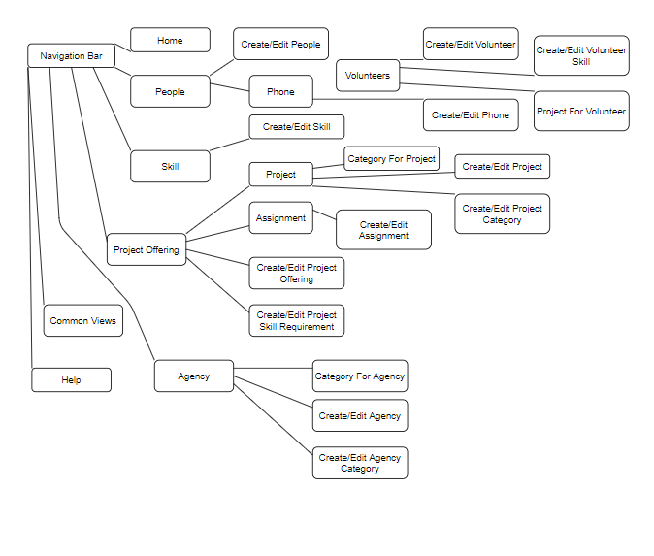

The system is built on Oracle Apex. It has a login page. This is a single user database. The program is structured around being able to access everything from the navigation bar. Like items are grouped with like items. Sub categories can be accessed using the drop down arrow in the navigation bar.

**Printouts of All SQL**

**CSO_create.sql**

create table people

( person_id number(3)

, first_name varchar2(50)

, last_name varchar2(50)

, street_address varchar2(200)

, city varchar2(50)

, state varchar2(50)

, zipcode varchar2(50)

, email varchar2(50)

, web_url varchar2(200)

, constraint people_pk primary key (person_id)

);

create table phone

( phone_id number(3)

, person_id number(3)

, phone_type varchar2(50)

, phone_number varchar2(50)

, constraint phone_pk primary key (phone_id)

, constraint phone_fk foreign key (person_id)

references people(person_id)

);

create table category_for_agency

( category_id number(3)

, category_name varchar2(50)

, description varchar2(50)

, constraint category_for_agency_pk primary key (category_id)

);

create table agency

( agency_id number(3)

, agency_name varchar2(50)

, street_address varchar2(200)

, city varchar2(50)

, state varchar2(50)

, zipcode varchar2(50)

, phone varchar2(50)

, email varchar2(50)

, web_url varchar2(200)

, contact_id number(3)

, constraint agency_pk primary key (agency_id)

, constraint agency_fk foreign key (contact_id)

references people(person_id)

);

create table agency_category

( agency_id number(3)

, category_id number(3)

, constraint agency_id_fk foreign key

references agency(agency_id)

, constraint category_id_fk foreign key

references category_for_agency(category_id)

);

create table category_for_project

( category_id number(3)

, category_name varchar2(50)

, description varchar2(50)

, constraint category_for_project_pk primary key (category_id)

);

create table project

( project_id number(3)

, description varchar2(50)

, agency_id number(3)

, constraint project_pk primary key (project_id)

, constraint project_fk foreign key

references agency(agency_id)

);

create table project_offering

( project_offering_id number(3)

, project_id number(3)

, project_date date

, contact_id number(3)

, num_volunteer varchar2(50)

, num_hour varchar2(50)

, constraint project_offering_pk primary key (project_offering_id)

, constraint project_offering_fk foreign key

references project(project_id)

, constraint project_offering_fk foreign key

references people(person_id)

);

create table project_category

( project_id number(3)

, category_id number(3)

, constraint project_category_fk foreign key

references project(project_id)

, constraint project_category_fk foreign key

references category_for_project(category_id)

);

create table volunteer

( volunteer_id number(3)

, person_id number(3)

, constraint volunteer_pk primary key (volunteer_id)

, constraint volunteer_fk foreign key

references people(person_id)

);

create table assignment

( assignment_id number(3)

, project_offering_id number(3)

, volunteer_id number(3)

, is_leader boolean

, constraint assignment_pk primary key (assignment_id)

, constraint assignment_fk foreign key

references project_offering(project_offering_id)

, constraint assignment_fk foreign key

references volunteer(volunteer_id)

);

create table skill

( skill_id number(3)

, skill_name varchar2(50)

, description varchar2(50)

, constraint skill_pk primary key (skill_id)

);

create table volunteer_skillset

( volunteer_id number(3)

, skill_id number(3)

, constraint volunteer_skillset_fk foreign key

references volunteer(volunteer_id)

, constraint volunteer_skillset_fk foreign key

references skill(skill_id)

);

create table project_skill_requirement

( project_id number(3)

, skill_id number(3)

, constraint project_skill_requirement_fk foreign key

references project(project_id)

, constraint project_skill_requirement_fk foreign key

references skill(skill_id)

);

CREATE SEQUENCE people_seq INCREMENT BY 1 START WITH 1;

CREATE SEQUENCE phone_seq INCREMENT BY 1 START WITH 1;

CREATE SEQUENCE category_for_agency_seq INCREMENT BY 1 START WITH 1;

CREATE SEQUENCE category_for_project_seq INCREMENT BY 1 START WITH 1;

CREATE SEQUENCE agency_seq INCREMENT BY 1 START WITH 1;

CREATE SEQUENCE project_seq INCREMENT BY 1 START WITH 1;

CREATE SEQUENCE project_offering_seq INCREMENT BY 1 START WITH 1;

CREATE SEQUENCE volunteer_seq INCREMENT BY 1 START WITH 1;

CREATE SEQUENCE assignment_seq INCREMENT BY 1 START WITH 1;

CREATE SEQUENCE skill_seq INCREMENT BY 1 START WITH 1;

CREATE OR REPLACE TRIGGER INSERT_people

BEFORE INSERT ON people

FOR EACH ROW

DECLARE

new_id number;

BEGIN

SELECT people_seq.nextval INTO new_id FROM dual;

:new.person_id := new_id;

END;

/

CREATE OR REPLACE TRIGGER INSERT_phone

BEFORE INSERT ON phone

FOR EACH ROW

DECLARE

new_id number;

BEGIN

SELECT phone_seq.nextval INTO new_id FROM dual;

:new.phone_id := new_id;

END;

/

CREATE OR REPLACE TRIGGER INSERT_category_for_agency

BEFORE INSERT ON category_for_agency

FOR EACH ROW

DECLARE

new_id number;

BEGIN

SELECT category_seq.nextval INTO new_id FROM dual;

:new.category_id := new_id;

END;

/

CREATE OR REPLACE TRIGGER INSERT_agency

BEFORE INSERT ON agency

FOR EACH ROW

DECLARE

new_id number;

BEGIN

SELECT agency_seq.nextval INTO new_id FROM dual;

:new.agency_id := new_id;

END;

/

CREATE OR REPLACE TRIGGER INSERT_category_for_project

BEFORE INSERT ON category_for_project

FOR EACH ROW

DECLARE

new_id number;

BEGIN

SELECT category_seq.nextval INTO new_id FROM dual;

:new.category_id := new_id;

END;

/

CREATE OR REPLACE TRIGGER INSERT_project

BEFORE INSERT ON project

FOR EACH ROW

DECLARE

new_id number;

BEGIN

SELECT project_seq.nextval INTO new_id FROM dual;

:new.project_id := new_id;

END;

/

CREATE OR REPLACE TRIGGER INSERT_project_offering

BEFORE INSERT ON project_offering

FOR EACH ROW

DECLARE

new_id number;

BEGIN

SELECT project_offering_seq.nextval INTO new_id FROM dual;

:new.project_offering_id := new_id;

END;

/

CREATE OR REPLACE TRIGGER INSERT_volunteer

BEFORE INSERT ON volunteer

FOR EACH ROW

DECLARE

new_id number;

BEGIN

SELECT volunteer_seq.nextval INTO new_id FROM dual;

:new.volunteer_id := new_id;

END;

/

CREATE OR REPLACE TRIGGER INSERT_assignment

BEFORE INSERT ON assignment

FOR EACH ROW

DECLARE

new_id number;

BEGIN

SELECT assignment_seq.nextval INTO new_id FROM dual;

:new.assignment_id := new_id;

END;

/

CREATE OR REPLACE TRIGGER INSERT_skill

BEFORE INSERT ON skill

FOR EACH ROW

DECLARE

new_id number;

BEGIN

SELECT skill_seq.nextval INTO new_id FROM dual;

:new.skill_id := new_id;

END;/

**CSO_insert.sql**

-- PEOPLE

INSERT INTO PEOPLE (FIRST_NAME, LAST_NAME, STREET_ADDRESS, CITY, STATE,

ZIPCODE, EMAIL, WEB_URL) VALUES ('James', 'Sanders', '789 Wayward Drive', 'Houston', 'TX', '34233', null, null);

INSERT INTO PEOPLE (FIRST_NAME, LAST_NAME, STREET_ADDRESS, CITY, STATE, ZIPCODE, EMAIL, WEB_URL) VALUES ('Robert', 'Smith', '39 Parkway', 'Dallas', 'TX', '34433', null, null);

INSERT INTO PEOPLE (FIRST_NAME, LAST_NAME, STREET_ADDRESS, CITY, STATE, ZIPCODE, EMAIL, WEB_URL) VALUES ('Scott', 'Dale', '200 Zoom Avenue', 'Boygan', 'MI', '21548', null, null);

INSERT INTO PEOPLE (FIRST_NAME, LAST_NAME, STREET_ADDRESS, CITY, STATE, ZIPCODE, EMAIL, WEB_URL) VALUES ('Lori', 'Meph', '349 Motel Lane', 'Brokesville', 'KY', '43254', null, null);

INSERT INTO PEOPLE (FIRST_NAME, LAST_NAME, STREET_ADDRESS, CITY, STATE, ZIPCODE, EMAIL, WEB_URL) VALUES ('Samantha', 'Smalls', '349 Biggs Street', 'Smalltown', 'AK', '21548', null, null);

INSERT INTO PEOPLE (FIRST_NAME, LAST_NAME, STREET_ADDRESS, CITY, STATE, ZIPCODE, EMAIL, WEB_URL) VALUES ('Rupert', 'Gint', '264 Hugwurts Place', 'Hugsmeade', 'CA', '21868', null, null);

INSERT INTO PEOPLE (FIRST_NAME, LAST_NAME, STREET_ADDRESS, CITY, STATE, ZIPCODE, EMAIL, WEB_URL) VALUES ('Timothy', 'Johnson', '520 Coffee Avenue', 'Huntsville', 'IL', '21128', null, null);

INSERT INTO PEOPLE (FIRST_NAME, LAST_NAME, STREET_ADDRESS, CITY, STATE, ZIPCODE, EMAIL, WEB_URL) VALUES ('Nemo', 'Wahala', '542 Wallaby Lane', 'Sydney', 'AU', '78945', null, null);

INSERT INTO PEOPLE (FIRST_NAME, LAST_NAME, STREET_ADDRESS, CITY, STATE, ZIPCODE, EMAIL, WEB_URL) VALUES ('Kyle', 'Cooman', '349 Imposter Street', 'Kansas City', 'MO', '61548', null, null);

INSERT INTO PEOPLE (FIRST_NAME, LAST_NAME, STREET_ADDRESS, CITY, STATE, ZIPCODE, EMAIL, WEB_URL) VALUES ('Jeff', 'Simpson', '390 Wannabe Lane', 'Marion', 'AL', '11520', null, null);

-- PHONE

INSERT INTO PHONE (PERSON_ID, PHONE_TYPE, PHONE_NUMBER) VALUES (1, 'HOME', '222-623-5427');

INSERT INTO PHONE (PERSON_ID, PHONE_TYPE, PHONE_NUMBER) VALUES (2, 'CELL', '340-458-4562');

INSERT INTO PHONE (PERSON_ID, PHONE_TYPE, PHONE_NUMBER) VALUES (3, 'HOME', '520-048-0540');

INSERT INTO PHONE (PERSON_ID, PHONE_TYPE, PHONE_NUMBER) VALUES (4, 'CELL', '204-805-0856');

INSERT INTO PHONE (PERSON_ID, PHONE_TYPE, PHONE_NUMBER) VALUES (5, 'WORK', '058-805-6752');

INSERT INTO PHONE (PERSON_ID, PHONE_TYPE, PHONE_NUMBER) VALUES (6, 'CELL', '079-805-5468');

INSERT INTO PHONE (PERSON_ID, PHONE_TYPE, PHONE_NUMBER) VALUES (7, 'HOME', '479-970-7564');

INSERT INTO PHONE (PERSON_ID, PHONE_TYPE, PHONE_NUMBER) VALUES (8, 'HOME', '852-258-7913');

INSERT INTO PHONE (PERSON_ID, PHONE_TYPE, PHONE_NUMBER) VALUES (9, 'WORK', '791-583-4568');

INSERT INTO PHONE (PERSON_ID, PHONE_TYPE, PHONE_NUMBER) VALUES (10, 'HOME', '528-468-8320');

-- CATEGORY_FOR_AGENCY

INSERT INTO CATEGORY_FOR_AGENCY (CATEGORY_ID, CATEGORY_NAME, DESCRIPTION) VALUES (1, 'Retirement Home', null);

INSERT INTO CATEGORY_FOR_AGENCY (CATEGORY_ID, CATEGORY_NAME, DESCRIPTION) VALUES (2, 'School', null);

INSERT INTO CATEGORY_FOR_AGENCY (CATEGORY_ID, CATEGORY_NAME, DESCRIPTION) VALUES (3, 'Church', null);

INSERT INTO CATEGORY_FOR_AGENCY (CATEGORY_ID, CATEGORY_NAME, DESCRIPTION) VALUES (4, 'Non-profit', null);

INSERT INTO CATEGORY_FOR_AGENCY (CATEGORY_ID, CATEGORY_NAME, DESCRIPTION) VALUES (5, 'Farm', null);

INSERT INTO CATEGORY_FOR_AGENCY (CATEGORY_ID, CATEGORY_NAME, DESCRIPTION) VALUES (6, 'Community', null);

INSERT INTO CATEGORY_FOR_AGENCY (CATEGORY_ID, CATEGORY_NAME, DESCRIPTION) VALUES (7, 'Cleaning', null);

INSERT INTO CATEGORY_FOR_AGENCY (CATEGORY_ID, CATEGORY_NAME, DESCRIPTION) VALUES (8, 'Parks', null);

INSERT INTO CATEGORY_FOR_AGENCY (CATEGORY_ID, CATEGORY_NAME, DESCRIPTION) VALUES (9, 'Fundraiser', null);

INSERT INTO CATEGORY_FOR_AGENCY (CATEGORY_ID, CATEGORY_NAME, DESCRIPTION) VALUES (10, 'Animal Shelter', null);

-- AGENCY

INSERT INTO AGENCY (AGENCY_ID, AGENCY_NAME, STREET_ADDRESS, CITY, STATE, ZIPCODE,PHONE, EMAIL, WEB_URL, CONTACT_ID) VALUES (1, 'Webster Works', '347 Gorlok Avenue', 'Saint Louis', 'MO', '63123', '314-548-4354', null, null, 1);

INSERT INTO AGENCY (AGENCY_ID, AGENCY_NAME, STREET_ADDRESS, CITY, STATE, ZIPCODE,PHONE, EMAIL, WEB_URL, CONTACT_ID) VALUES (2, 'Volunteerism', '348 Arch Road', 'Chicago', 'IL', '60345', '341-944-4985', null, null, 3);

INSERT INTO AGENCY (AGENCY_ID, AGENCY_NAME, STREET_ADDRESS, CITY, STATE, ZIPCODE,PHONE, EMAIL, WEB_URL, CONTACT_ID) VALUES (3, 'Holy Hands', '977 Pumpkin Hill Street', 'Brownsburg', 'IN', '46112', '123-354-8204', null, null, 5);

INSERT INTO AGENCY (AGENCY_ID, AGENCY_NAME, STREET_ADDRESS, CITY, STATE, ZIPCODE,PHONE, EMAIL, WEB_URL, CONTACT_ID) VALUES (4, 'Happy Helpers', '991 Boston St', 'Baldwinsville', 'NY', '20772', '145-724-4502', null, null, 3);

INSERT INTO AGENCY (AGENCY_ID, AGENCY_NAME, STREET_ADDRESS, CITY, STATE, ZIPCODE,PHONE, EMAIL, WEB_URL, CONTACT_ID) VALUES (5, 'Cleanup Crew', '52 Winding Way Avenue', 'West Roxbury', 'MA', '02132', '972-275-5025', null, null, 3);

INSERT INTO AGENCY (AGENCY_ID, AGENCY_NAME, STREET_ADDRESS, CITY, STATE, ZIPCODE,PHONE, EMAIL, WEB_URL, CONTACT_ID) VALUES (6, 'Positive People', '130 Glenwwod Street', 'Upper Marlboro', 'MD', '20772', '250-522-7920', null, null, 1);

INSERT INTO AGENCY (AGENCY_ID, AGENCY_NAME, STREET_ADDRESS, CITY, STATE, ZIPCODE,PHONE, EMAIL, WEB_URL, CONTACT_ID) VALUES (7, 'Local Love', '7650 Jefferson Drive', 'Far Rockaway', 'NY', '11691', '648-852-6852', null, null, 9);

INSERT INTO AGENCY (AGENCY_ID, AGENCY_NAME, STREET_ADDRESS, CITY, STATE, ZIPCODE,PHONE, EMAIL, WEB_URL, CONTACT_ID) VALUES (8, 'American Heart Association', '61 Lantern Street', 'Tualatin', 'OR', '97062', '005-582-9777', null, null, 1);

INSERT INTO AGENCY (AGENCY_ID, AGENCY_NAME, STREET_ADDRESS, CITY, STATE, ZIPCODE,PHONE, EMAIL, WEB_URL, CONTACT_ID) VALUES (9, 'CaringBridge', '669 N. Peg Shop Drive', 'Danville', 'VA', '24540', '085-852-5552', null, null, 3);

INSERT INTO AGENCY (AGENCY_ID, AGENCY_NAME, STREET_ADDRESS, CITY, STATE, ZIPCODE,PHONE, EMAIL, WEB_URL, CONTACT_ID) VALUES (10, 'American Red Cross', '7989 Shady Drive', 'Loveland', 'OH', '45140', '879-997-8520', null, null, 10);

-- CATEGORY_FOR_PROJECT

INSERT INTO CATEGORY_FOR_PROJECT (CATEGORY_ID, CATEGORY_NAME, DESCRIPTION) VALUES (1, 'Cleaning',null);

INSERT INTO CATEGORY_FOR_PROJECT (CATEGORY_ID, CATEGORY_NAME, DESCRIPTION) VALUES (2, 'Cooking',null);

INSERT INTO CATEGORY_FOR_PROJECT (CATEGORY_ID, CATEGORY_NAME, DESCRIPTION) VALUES (3, 'Elderly Assistance',null);

INSERT INTO CATEGORY_FOR_PROJECT (CATEGORY_ID, CATEGORY_NAME, DESCRIPTION) VALUES (4, 'Croptending',null);

INSERT INTO CATEGORY_FOR_PROJECT (CATEGORY_ID, CATEGORY_NAME, DESCRIPTION) VALUES (5, 'Sewing',null);

INSERT INTO CATEGORY_FOR_PROJECT (CATEGORY_ID, CATEGORY_NAME, DESCRIPTION) VALUES (6, 'Animal Care',null);

INSERT INTO CATEGORY_FOR_PROJECT (CATEGORY_ID, CATEGORY_NAME, DESCRIPTION) VALUES (7, 'Nursing',null);

INSERT INTO CATEGORY_FOR_PROJECT (CATEGORY_ID, CATEGORY_NAME, DESCRIPTION) VALUES (8, 'Entertaining',null);

INSERT INTO CATEGORY_FOR_PROJECT (CATEGORY_ID, CATEGORY_NAME, DESCRIPTION) VALUES (9, 'Event Planning',null);

INSERT INTO CATEGORY_FOR_PROJECT (CATEGORY_ID, CATEGORY_NAME, DESCRIPTION) VALUES (10, 'Catering',null);

-- PROJECT

INSERT INTO PROJECT (PROJECT_ID, DESCRIPTION, AGENCY_ID) VALUES (1, 'Downtown Cleanup', 1);

INSERT INTO PROJECT (PROJECT_ID, DESCRIPTION, AGENCY_ID) VALUES (2, 'Caring Kitchen', 3);

INSERT INTO PROJECT (PROJECT_ID, DESCRIPTION, AGENCY_ID) VALUES (3, 'Lunch With The Golden Gals', 5);

INSERT INTO PROJECT (PROJECT_ID, DESCRIPTION, AGENCY_ID) VALUES (4, 'St Catherines Bake Sale', 1);

INSERT INTO PROJECT (PROJECT_ID, DESCRIPTION, AGENCY_ID) VALUES (5, 'Adoption Day', 7);

INSERT INTO PROJECT (PROJECT_ID, DESCRIPTION, AGENCY_ID) VALUES (6, 'Local Park', 8);

INSERT INTO PROJECT (PROJECT_ID, DESCRIPTION, AGENCY_ID) VALUES (7, 'Sew Warm', 8);

INSERT INTO PROJECT (PROJECT_ID, DESCRIPTION, AGENCY_ID) VALUES (8, 'Farmer Johns Farmers', 10);

INSERT INTO PROJECT (PROJECT_ID, DESCRIPTION, AGENCY_ID) VALUES (9, 'Bakesale', 8);

INSERT INTO PROJECT (PROJECT_ID, DESCRIPTION, AGENCY_ID) VALUES (10, 'Youth Day', 2);

-- PROJECT_OFFERING

INSERT INTO PROJECT_OFFERING (PROJECT_OFFERING_ID, PROJECT_ID, PROJECT_DATE, CONTACT_ID, NUM_VOLUNTEER, NUM_HOUR) VALUES (1, 1, 2020-03-22, 1, '6', '3');

INSERT INTO PROJECT_OFFERING (PROJECT_OFFERING_ID, PROJECT_ID, PROJECT_DATE, CONTACT_ID, NUM_VOLUNTEER, NUM_HOUR) VALUES (2, 2, 2020-04-12, 2, '10', '2');

INSERT INTO PROJECT_OFFERING (PROJECT_OFFERING_ID, PROJECT_ID, PROJECT_DATE, CONTACT_ID, NUM_VOLUNTEER, NUM_HOUR) VALUES (3, 3, 2021-05-08, 3, '20', '1.5');

INSERT INTO PROJECT_OFFERING (PROJECT_OFFERING_ID, PROJECT_ID, PROJECT_DATE, CONTACT_ID, NUM_VOLUNTEER, NUM_HOUR) VALUES (4, 4, 2022-10-10, 4, '15', '6');

INSERT INTO PROJECT_OFFERING (PROJECT_OFFERING_ID, PROJECT_ID, PROJECT_DATE, CONTACT_ID, NUM_VOLUNTEER, NUM_HOUR) VALUES (5, 5, 2020-07-07, 5, '3', '7');

INSERT INTO PROJECT_OFFERING (PROJECT_OFFERING_ID, PROJECT_ID, PROJECT_DATE, CONTACT_ID, NUM_VOLUNTEER, NUM_HOUR) VALUES (6, 6, 2020-06-01, 6, '6', '6');

INSERT INTO PROJECT_OFFERING (PROJECT_OFFERING_ID, PROJECT_ID, PROJECT_DATE, CONTACT_ID, NUM_VOLUNTEER, NUM_HOUR) VALUES (7, 7, 2020-04-10, 7, '10', '2');

INSERT INTO PROJECT_OFFERING (PROJECT_OFFERING_ID, PROJECT_ID, PROJECT_DATE, CONTACT_ID, NUM_VOLUNTEER, NUM_HOUR) VALUES (8, 8, 2020-02-22, 8, '1', '5');

INSERT INTO PROJECT_OFFERING (PROJECT_OFFERING_ID, PROJECT_ID, PROJECT_DATE, CONTACT_ID, NUM_VOLUNTEER, NUM_HOUR) VALUES (9, 9, 2020-05-05, 9, '5', '2');

INSERT INTO PROJECT_OFFERING (PROJECT_OFFERING_ID, PROJECT_ID, PROJECT_DATE, CONTACT_ID, NUM_VOLUNTEER, NUM_HOUR) VALUES (10, 10, 2020-06-16, 10, '15', '3');

-- VOLUNTEER

INSERT INTO VOLUNTEER (VOLUNTEER_ID, PERSON_ID) VALUES (1, 1);

INSERT INTO VOLUNTEER (VOLUNTEER_ID, PERSON_ID) VALUES (2, 2);

INSERT INTO VOLUNTEER (VOLUNTEER_ID, PERSON_ID) VALUES (3, 3);

INSERT INTO VOLUNTEER (VOLUNTEER_ID, PERSON_ID) VALUES (4, 4);

INSERT INTO VOLUNTEER (VOLUNTEER_ID, PERSON_ID) VALUES (5, 5);

INSERT INTO VOLUNTEER (VOLUNTEER_ID, PERSON_ID) VALUES (6, 6);

INSERT INTO VOLUNTEER (VOLUNTEER_ID, PERSON_ID) VALUES (7, 7);

INSERT INTO VOLUNTEER (VOLUNTEER_ID, PERSON_ID) VALUES (8, 8);

INSERT INTO VOLUNTEER (VOLUNTEER_ID, PERSON_ID) VALUES (9, 9);

INSERT INTO VOLUNTEER (VOLUNTEER_ID, PERSON_ID) VALUES (10, 10);

-- ASSIGNMENT

INSERT INTO ASSIGNMENT (ASSIGNMENT_ID, PROJECT_OFFERING_ID, VOLUNTEER_ID, IS_LEADER) VALUES (1, 1, 1, 'yes');

INSERT INTO ASSIGNMENT (ASSIGNMENT_ID, PROJECT_OFFERING_ID, VOLUNTEER_ID, IS_LEADER) VALUES (2, 2, 2, 'yes');

INSERT INTO ASSIGNMENT (ASSIGNMENT_ID, PROJECT_OFFERING_ID, VOLUNTEER_ID, IS_LEADER) VALUES (3, 3, 3, 'yes');

INSERT INTO ASSIGNMENT (ASSIGNMENT_ID, PROJECT_OFFERING_ID, VOLUNTEER_ID, IS_LEADER) VALUES (4, 4, 4, 'no');

INSERT INTO ASSIGNMENT (ASSIGNMENT_ID, PROJECT_OFFERING_ID, VOLUNTEER_ID, IS_LEADER) VALUES (5, 5, 5, 'no');

INSERT INTO ASSIGNMENT (ASSIGNMENT_ID, PROJECT_OFFERING_ID, VOLUNTEER_ID, IS_LEADER) VALUES (6, 6, 6, 'yes');

INSERT INTO ASSIGNMENT (ASSIGNMENT_ID, PROJECT_OFFERING_ID, VOLUNTEER_ID, IS_LEADER) VALUES (7, 7, 7, 'yes');

INSERT INTO ASSIGNMENT (ASSIGNMENT_ID, PROJECT_OFFERING_ID, VOLUNTEER_ID, IS_LEADER) VALUES (8, 8, 8, 'no');

INSERT INTO ASSIGNMENT (ASSIGNMENT_ID, PROJECT_OFFERING_ID, VOLUNTEER_ID, IS_LEADER) VALUES (9, 9, 9, 'no');

INSERT INTO ASSIGNMENT (ASSIGNMENT_ID, PROJECT_OFFERING_ID, VOLUNTEER_ID, IS_LEADER) VALUES (10, 10, 10, 'yes');

--SKILL

INSERT INTO SKILL (SKILL_ID, SKILL_NAME, DESCRIPTION) VALUES (1, 'Cooking', null);

INSERT INTO SKILL (SKILL_ID, SKILL_NAME, DESCRIPTION) VALUES (2, 'Public Speaking', null);

INSERT INTO SKILL (SKILL_ID, SKILL_NAME, DESCRIPTION) VALUES (3, 'Cleaning', null);

INSERT INTO SKILL (SKILL_ID, SKILL_NAME, DESCRIPTION) VALUES (4, 'Botany', null);

INSERT INTO SKILL (SKILL_ID, SKILL_NAME, DESCRIPTION) VALUES (5, 'Catering', null);

INSERT INTO SKILL (SKILL_ID, SKILL_NAME, DESCRIPTION) VALUES (6, 'Heavy Lifting', null);

INSERT INTO SKILL (SKILL_ID, SKILL_NAME, DESCRIPTION) VALUES (7, 'Sewing', null);

INSERT INTO SKILL (SKILL_ID, SKILL_NAME, DESCRIPTION) VALUES (8, 'Driving', null);

INSERT INTO SKILL (SKILL_ID, SKILL_NAME, DESCRIPTION) VALUES (9, 'Performing', null);

INSERT INTO SKILL (SKILL_ID, SKILL_NAME, DESCRIPTION) VALUES (10, 'Baking', null);

--AGENCY_CATEGORY

INSERT INTO AGENCY_CATEGORY (AGENCY_ID, CATEGORY_ID) VALUES (1,1);

INSERT INTO AGENCY_CATEGORY (AGENCY_ID, CATEGORY_ID) VALUES (2,2);

INSERT INTO AGENCY_CATEGORY (AGENCY_ID, CATEGORY_ID) VALUES (3,3);

INSERT INTO AGENCY_CATEGORY (AGENCY_ID, CATEGORY_ID) VALUES (4,4);

INSERT INTO AGENCY_CATEGORY (AGENCY_ID, CATEGORY_ID) VALUES (5,5);

INSERT INTO AGENCY_CATEGORY (AGENCY_ID, CATEGORY_ID) VALUES (6,6);

INSERT INTO AGENCY_CATEGORY (AGENCY_ID, CATEGORY_ID) VALUES (7,7);

INSERT INTO AGENCY_CATEGORY (AGENCY_ID, CATEGORY_ID) VALUES (8,8);

INSERT INTO AGENCY_CATEGORY (AGENCY_ID, CATEGORY_ID) VALUES (9,9);

INSERT INTO AGENCY_CATEGORY (AGENCY_ID, CATEGORY_ID) VALUES (10,10);

--VOLUNTEER_SKILLSET

INSERT INTO VOLUNTEER_SKILLSET (VOLUNTEER_ID, SKILL_ID) VALUES (1,1);

INSERT INTO VOLUNTEER_SKILLSET (VOLUNTEER_ID, SKILL_ID) VALUES (2,2);

INSERT INTO VOLUNTEER_SKILLSET (VOLUNTEER_ID, SKILL_ID) VALUES (3,3);

INSERT INTO VOLUNTEER_SKILLSET (VOLUNTEER_ID, SKILL_ID) VALUES (4,4);

INSERT INTO VOLUNTEER_SKILLSET (VOLUNTEER_ID, SKILL_ID) VALUES (5,5);

INSERT INTO VOLUNTEER_SKILLSET (VOLUNTEER_ID, SKILL_ID) VALUES (6,6);

INSERT INTO VOLUNTEER_SKILLSET (VOLUNTEER_ID, SKILL_ID) VALUES (7,7);

INSERT INTO VOLUNTEER_SKILLSET (VOLUNTEER_ID, SKILL_ID) VALUES (8,8);

INSERT INTO VOLUNTEER_SKILLSET (VOLUNTEER_ID, SKILL_ID) VALUES (9,9);

INSERT INTO VOLUNTEER_SKILLSET (VOLUNTEER_ID, SKILL_ID) VALUES (10,10);

--PROJECT_SKILL_REQUIREMENT

INSERT INTO PROJECT_SKILL_REQUIREMENT (PROJECT_ID, SKILL_ID)

VALUES (1,1);

INSERT INTO PROJECT_SKILL_REQUIREMENT (PROJECT_ID, SKILL_ID)

VALUES (2,2);

INSERT INTO PROJECT_SKILL_REQUIREMENT (PROJECT_ID, SKILL_ID)

VALUES (3,3);

INSERT INTO PROJECT_SKILL_REQUIREMENT (PROJECT_ID, SKILL_ID)

VALUES (4,4);

INSERT INTO PROJECT_SKILL_REQUIREMENT (PROJECT_ID, SKILL_ID)

VALUES (5,5);

INSERT INTO PROJECT_SKILL_REQUIREMENT (PROJECT_ID, SKILL_ID)

VALUES (6,6);

INSERT INTO PROJECT_SKILL_REQUIREMENT (PROJECT_ID, SKILL_ID)

VALUES (7,7);

INSERT INTO PROJECT_SKILL_REQUIREMENT (PROJECT_ID, SKILL_ID)

VALUES (8,8);

INSERT INTO PROJECT_SKILL_REQUIREMENT (PROJECT_ID, SKILL_ID)

VALUES (9,9);

INSERT INTO PROJECT_SKILL_REQUIREMENT (PROJECT_ID, SKILL_ID)

VALUES (10,10);

--PROJECT_CATEGORY

INSERT INTO PROJECT_CATEGORY (PROJECT_ID, CATEGORY_ID) VALUES (1,1);

INSERT INTO PROJECT_CATEGORY (PROJECT_ID, CATEGORY_ID) VALUES (2,2);

INSERT INTO PROJECT_CATEGORY (PROJECT_ID, CATEGORY_ID) VALUES (3,3);

INSERT INTO PROJECT_CATEGORY (PROJECT_ID, CATEGORY_ID) VALUES (4,4);

INSERT INTO PROJECT_CATEGORY (PROJECT_ID, CATEGORY_ID) VALUES (5,5);

INSERT INTO PROJECT_CATEGORY (PROJECT_ID, CATEGORY_ID) VALUES (6,6);

INSERT INTO PROJECT_CATEGORY (PROJECT_ID, CATEGORY_ID) VALUES (7,7);

INSERT INTO PROJECT_CATEGORY (PROJECT_ID, CATEGORY_ID) VALUES (8,8);

INSERT INTO PROJECT_CATEGORY (PROJECT_ID, CATEGORY_ID) VALUES (9,9);

INSERT INTO PROJECT_CATEGORY (PROJECT_ID, CATEGORY_ID) VALUES (10,10);

**CSO_drop.sql**

alter table phone drop constraint phone_fk;

alter table agency drop constraint agency_fk;

alter table agency_category drop constraint agency_id_fk;

alter table agency_category drop constraint category_id_fk;

alter table project drop constraint project_fk;

alter table project_offering drop constraint project_offering_project_fk;

alter table project_offering drop constraint project_offering_people_fk;

alter table project_category drop constraint project_category_project_fk;

alter table project_category drop constraint project_category_category_fk;

alter table volunteer drop constraint volunteer_fk;

alter table assignment drop constraint assignment_project_offering_fk;

alter table assignment drop constraint assignment_volunteer_fk;

alter table volunteer_skillset drop constraint volunteer_skillset_volunteer_fk;

alter table volunteer_skillset drop constraint volunteer_skillset_skill_fk;

alter table project_skill_requirement drop constraint project_skill_requirement_project_fk;

alter table project_skill_requirement drop constraint project_skill_requirement_skill_fk;

drop table people;

drop table phone;

drop table category_for_agency;

drop table agency;

drop table agency_category;

drop table category_for_project;

drop table project;

drop table project_offering;

drop table project_category;

drop table volunteer;

drop table assignment;

drop table skill;

drop table volunteer_skillset;

drop table project_skill_requirement;

DROP SEQUENCE people_seq;

DROP SEQUENCE phone_seq;

DROP SEQUENCE category_for_agency_seq;

DROP SEQUENCE category_for_project_seq;

DROP SEQUENCE agency_seq;

DROP SEQUENCE project_seq;

DROP SEQUENCE project_offering_seq;

DROP SEQUENCE volunteer_seq;

DROP SEQUENCE assignment_seq;

DROP SEQUENCE skill_seq;

**Printouts of Sample Data**

**Agency**

"AGENCY_ID","AGENCY_NAME","STREET_ADDRESS","CITY","STATE","ZIPCODE","PHONE","EMAIL","WEB_URL","CONTACT_ID"

"1","Webster Works","347 Gorlok Avenue","Saint Louis","MO","63123","314-548-4354","","","1"

"2","Volunteerism","348 Arch Road","Chicago","IL","60345","341-944-4985","","","3"

"3","Holy Hands","977 Pumpkin Hill Street","Brownsburg","IN","46112","123-354-8204","","","5"

"4","Happy Helpers","991 Boston St","Baldwinsville","NY","20772","145-724-4502","","","3"

"5","Cleanup Crew","52 Winding Way Avenue","West Roxbury","MA","02132","972-275-5025","","","3"

"6","Positive People","130 Glenwwod Street","Upper Marlboro","MD","20772","250-522-7920","","","1"

"7","Local Love","7650 Jefferson Drive","Far Rockaway","NY","11691","648-852-6852","","","9"

"8","American Heart Association","61 Lantern Street","Tualatin","OR","97062","005-582-9777","","","1"

"9","CaringBridge","669 N. Peg Shop Drive","Danville","VA","24540","085-852-5552","","","3"

"10","American Red Cross","7989 Shady Drive","Loveland","OH","45140","879-997-8520","","","10"

**Agency_Category**

"AGENCY_ID","CATEGORY_ID"

"1","1"

"2","2"

"3","3"

"4","4"

"5","5"

"6","6"

"7","7"

"8","8"

"9","9"

"10","10"

**Assignment**

"ASSIGNMENT_ID","PROJECT_OFFERING_ID","VOLUNTEER_ID","IS_LEADER"

"1","1","1","yes"

"2","2","2","yes"

"3","3","3","yes"

"4","4","4","no"

"5","5","5","no"

"6","6","6","yes"

"7","7","7","yes"

"8","8","8","no"

"9","9","9","no"

"10","10","10","yes"

**Category_For_Agency**

"CATEGORY_ID","CATEGORY_NAME","DESCRIPTION"

"1","Retirement Home",""

"2","School",""

"3","Church",""

"4","Non-profit",""

"5","Farm",""

"6","Community",""

"7","Cleaning",""

"8","Parks",""

"9","Fundraiser",""

"10","Animal Shelter",""

**Category_For_Project**

"CATEGORY_ID","CATEGORY_NAME","DESCRIPTION"

"1","Cleaning",""

"2","Cooking",""

"3","Elderly Assistance",""

"4","Croptending",""

"5","Sewing",""

"6","Animal Care",""

"7","Nursing",""

"8","Entertaining",""

"9","Event Planning",""

"10","Catering",""

**People**

"PERSON_ID","FIRST_NAME","LAST_NAME","STREET_ADDRESS","CITY","STATE","ZIPCODE","EMAIL","WEB_URL"

"1","James","Sanders","789 Wayward Drive","Houston","TX","34233","",""

"2","Robert","Smith","39 Parkway","Dallas","TX","34433","",""

"3","Scott","Dale","200 Zoom Avenue","Boygan","MI","21548","",""

"4","Lori","Meph","349 Motel Lane","Brokesville","KY","43254","",""

"5","Samantha","Smalls","349 Biggs Street","Smalltown","AK","21548","",""

"6","Rupert","Gint","264 Hugwurts Place","Hugsmeade","CA","21868","",""

"7","Timothy","Johnson","520 Coffee Avenue","Huntsville","IL","21128","",""

"8","Nemo","Wahala","542 Wallaby Lane","Sydney","AU","78945","",""

"9","Kyle","Cooman","349 Imposter Street","Kansas City","MO","61548","",""

"10","Jeff","Simpson","390 Wannabe Lane","Marion","AL","11520","",""

**Phone**

"PHONE_ID","PERSON_ID","PHONE_TYPE","PHONE_NUMBER"

"1","1","HOME","222-623-5427"

"2","2","CELL","340-458-4562"

"3","3","HOME","520-048-0540"

"4","4","CELL","204-805-0856"

"5","5","WORK","058-805-6752"

"6","6","CELL","079-805-5468"

"7","7","HOME","479-970-7564"

"8","8","HOME","852-258-7913"

"9","9","WORK","791-583-4568"

"10","10","HOME","528-468-8320"

**Project**

"PROJECT_ID","DESCRIPTION","AGENCY_ID"

"1","Downtown Cleanup","1"

"2","Caring Kitchen","3"

"3","Lunch With The Golden Gals","5"

"4","St Catherines Bake Sale","1"

"5","Adoption Day","7"

"6","Local Park","8"

"7","Sew Warm","8"

"8","Farmer Johns Farmers","10"

"9","Bakesale","8"

"10","Youth Day","2"

**Project_Category**

"PROJECT_ID","CATEGORY_ID"

"1","1"

"2","2"

"3","3"

"4","4"

"5","5"

"6","6"

"7","7"

"8","8"

"9","9"

"10","10"

**Project_Offering**

"PROJECT_OFFERING_ID","PROJECT_ID","PROJECT_DATE","CONTACT_ID","NUM_VOLUNTEER","NUM_HOUR"

"1","1","1995","1","6","3"

"2","2","2004","2","10","2"

"3","3","2008","3","20","1.5"

"4","4","2002","4","15","6"

"5","5","2006","5","3","7"

"6","6","2013","6","6","6"

"7","7","2006","7","10","2"

"8","8","1996","8","1","5"

"9","9","2010","9","5","2"

"10","10","1998","10","15","3"

**Project_Skill_Requirement**

"PROJECT_ID","SKILL_ID"

"1","1"

"2","2"

"3","3"

"4","4"

"5","5"

"6","6"

"7","7"

"8","8"

"9","9"

"10","10"

**Skill**

"SKILL_ID","SKILL_NAME","DESCRIPTION"

"1","Cooking",""

"2","Public Speaking",""

"3","Cleaning",""

"4","Botany",""

"5","Catering",""

"6","Heavy Lifting",""

"7","Sewing",""

"8","Driving",""

"9","Performing",""

"10","Baking",""

**Volunteer**

"VOLUNTEER_ID","PERSON_ID"

"1","1"

"2","2"

"3","3"

"4","4"

"5","5"

"6","6"

"7","7"

"8","8"

"9","9"

"10","10"

**Volunteer_Skillset**

"VOLUNTEER_ID","SKILL_ID"

"1","1"

"2","2"

"3","3"

"4","4"

"5","5"

"6","6"

"7","7"

"8","8"

"9","9"

"10","10"